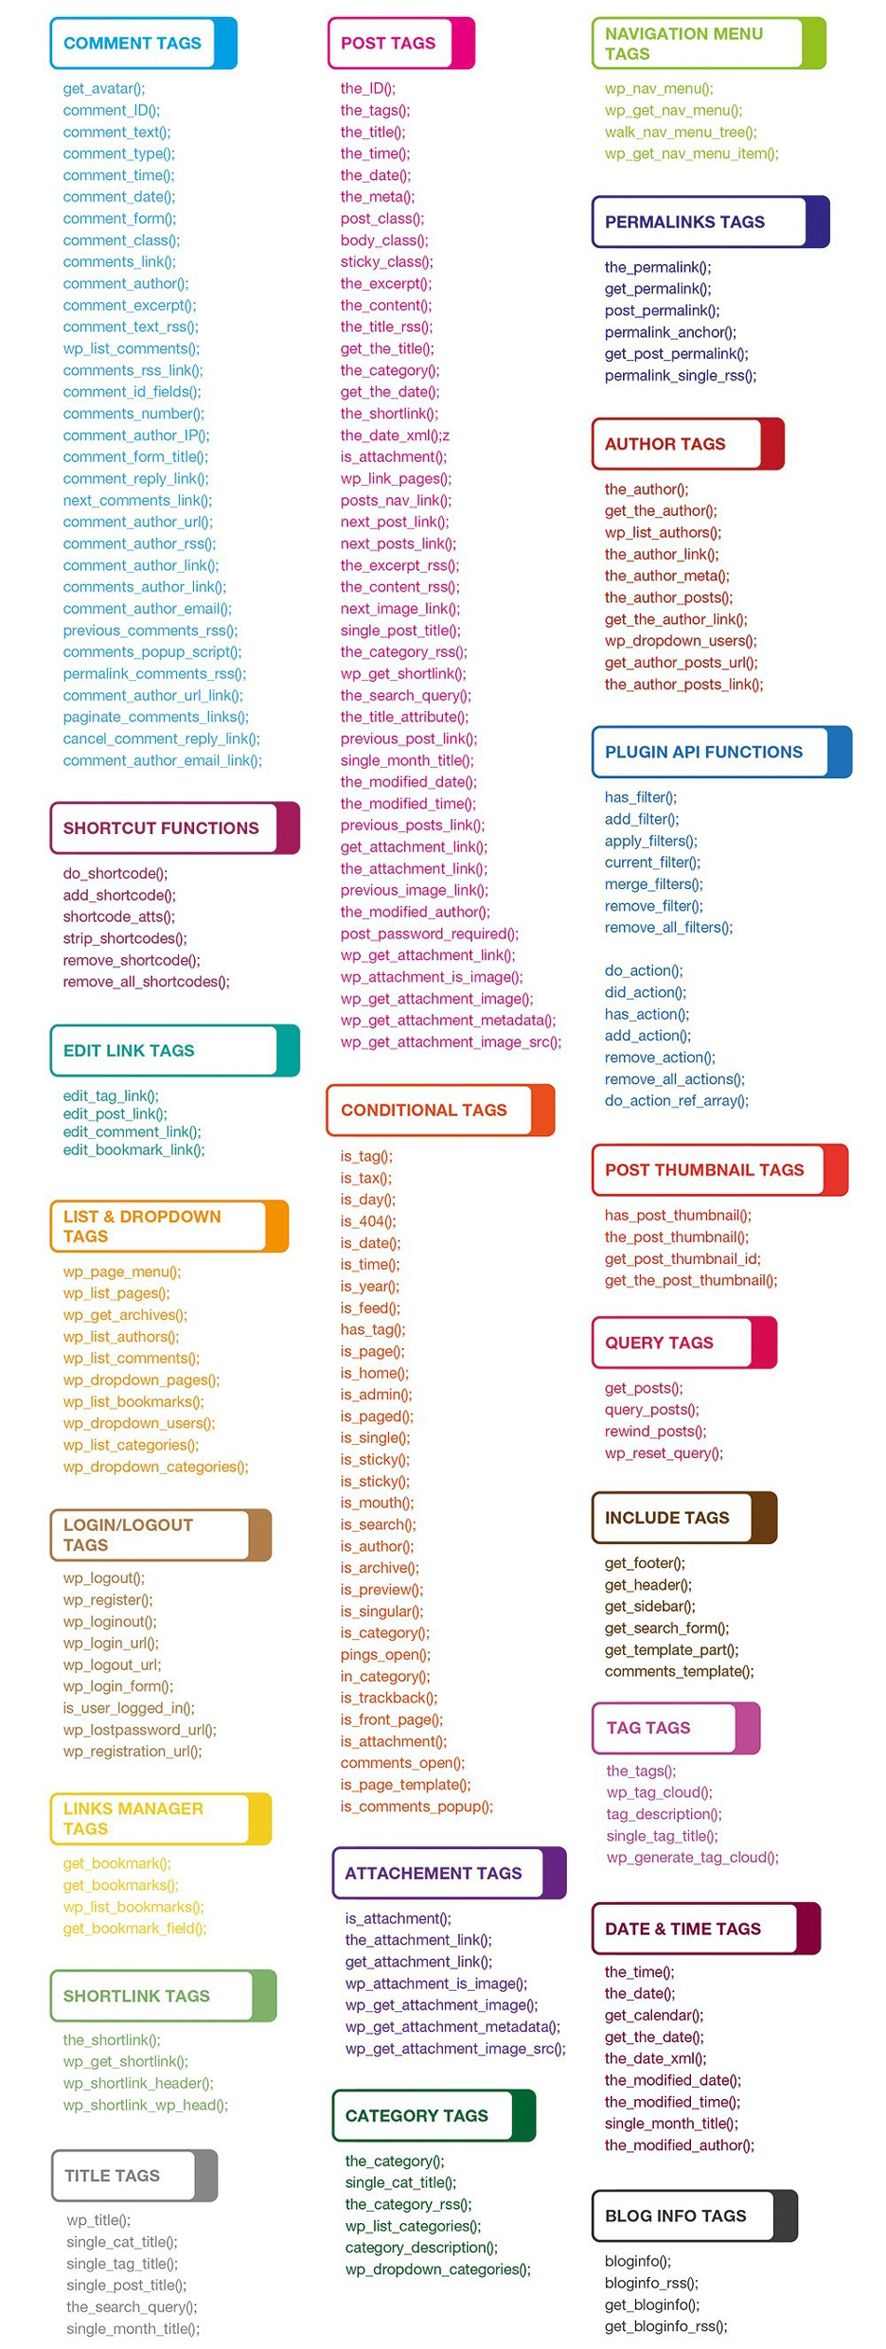

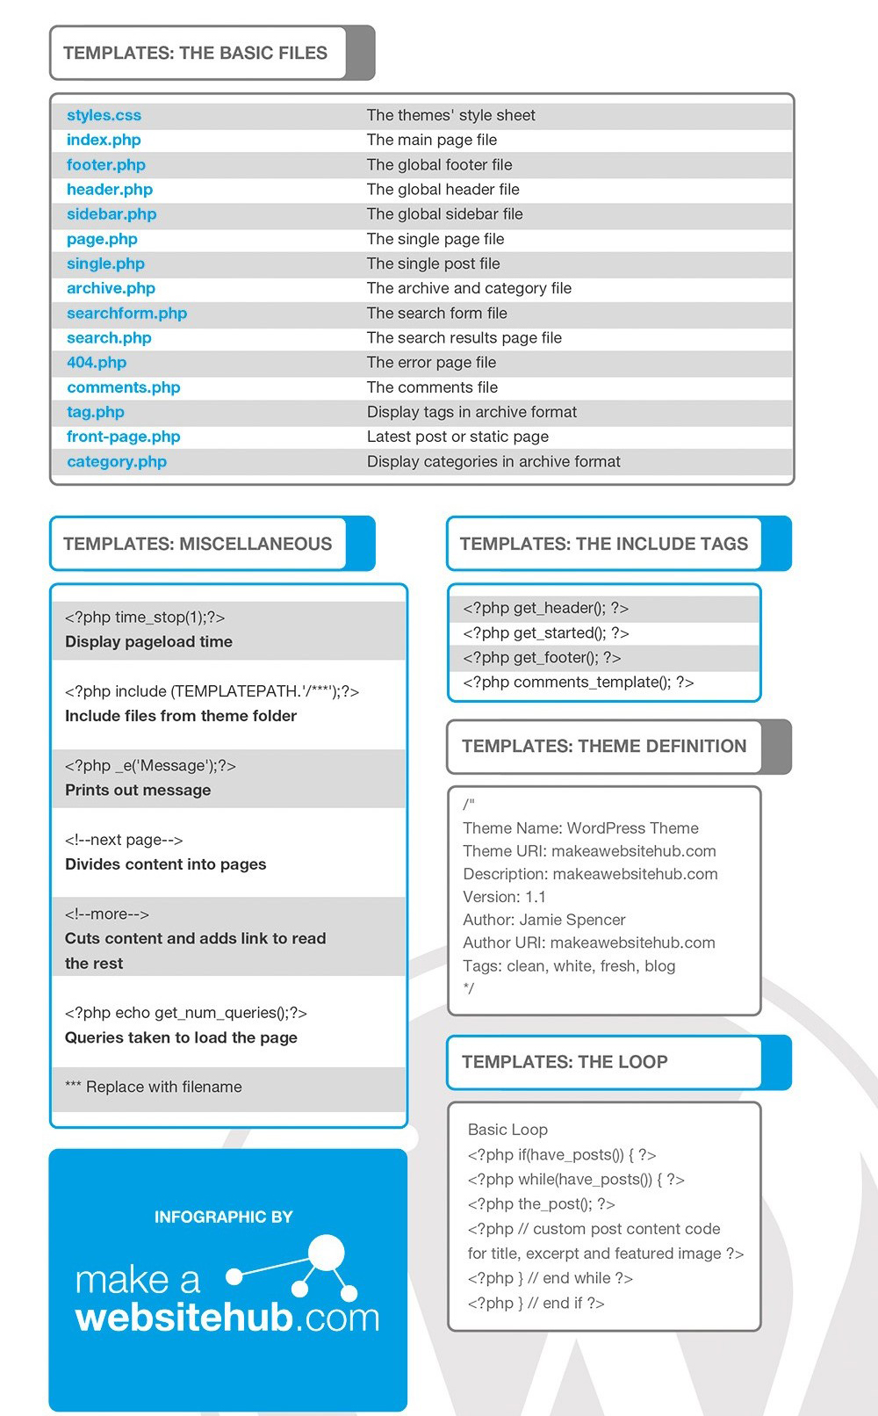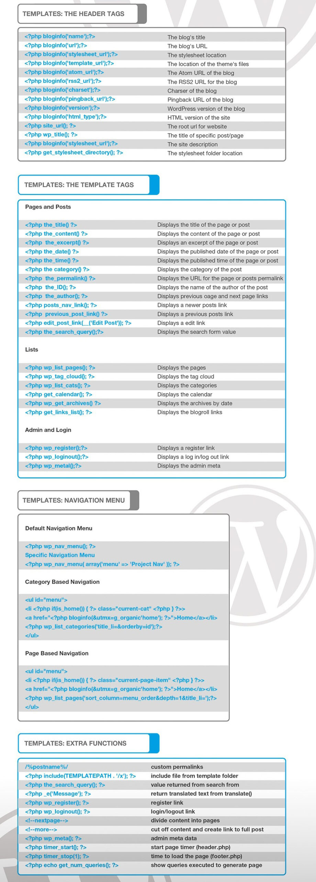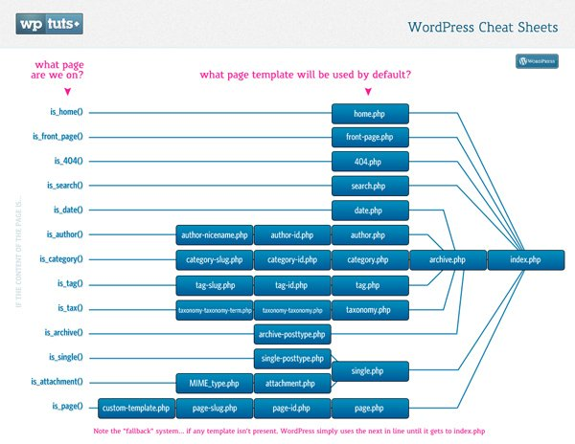

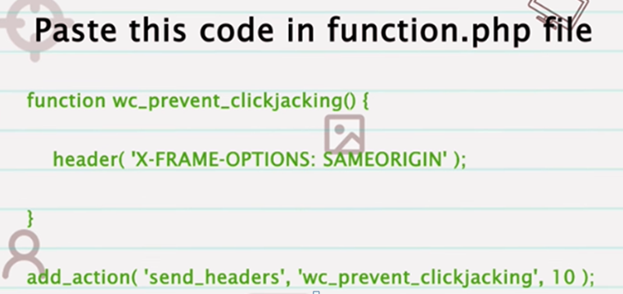

**WordPress Security**

1. **Checking User Capabilities**
2. **Data Validation**
3. **Securing (sanitizing) Input**
4. **Securing (escaping) Output**
5. **Nonces**
6. **XML-RPC issue**
7. **Directory listing issue**
8. **Internal path disclosure**
9. **Server signature**
10. **SQL Injection**
11. **Clickjacking**
12. **WordPress version**
13. **Login URL exposed**
14. **Robots.txt Disclosure**

**1.Keep WordPress Updated:**

**2.Use Strong Passwords:**

**3.Limit Login Attempts:**

**4.Implement Two-Factor Authentication (2FA):**

**5.Secure Hosting Environment:**

**6.Use SSL/TLS Encryption:**

**7.Regular Backups:**

**8.Use Trusted Themes and Plugins:**

**9.Limit File and Directory Permissions:**

**10.Monitor for Suspicious Activity:**

**11.Install Security Plugins:**

**12.Implement a Web Application Firewall (WAF):**

**White Screen of Death" (WSOD), is a common issue**

* **Disable plugin**
* **Change your default theme**
* **Increase php memory size**
* **Checking Error log**
* **Enable WP Debug mode**
* **Enable debug log**
* **Enable Debug Display**
* **Enable Script debug**
* **Checking WP Debug php error**
* **Check for Plugin or Theme Conflicts:**
* **Increase PHP Memory Limit:**
* **Check for Syntax Errors:**
* **Server Error Logs:**
* **Corrupted Core Files:**
* **Browser Cache:**
* **Disable and Re-enable Theme or Plugin:**
* **WordPress Debugging Tools:**
* **Consult Hosting Support:**

**define('WP_DEBUG', true);**

**define('WP_DEBUG_LOG', true);**

**define('WP_DEBUG_DISPLAY', false);**

**This will log errors to a debug.log file in the /wp-content/ directory.**

**Check for Plugin or Theme Conflicts:**

Deactivate all plugins by renaming the plugins folder inside the /wp-content/ directory to something else (e.g., plugins_old). If this resolves the issue, it means one of your plugins is causing the problem. Reactivate them one by one to identify the problematic plugin.

If the issue persists after disabling plugins, switch to a default WordPress theme (e.g., Twenty Twenty-One) by renaming your current theme's folder inside the /wp-content/themes/ directory.

**Increase PHP Memory Limit:**

A lack of memory can sometimes cause the white screen. Increase your PHP memory limit by adding the following line to your wp-config.php file:

**define('WP_MEMORY_LIMIT', '256M');**

**Check for Syntax Errors:**

Review recent changes to your theme or plugin files. Syntax errors in PHP code can cause a white screen.

**Server Error Logs:**

Check your server's error logs (typically found in cPanel, Plesk, or through SSH access). Look for any PHP errors or server-related issues that might be causing the white screen.

Database Issues:

Sometimes database problems can lead to a white screen. Ensure your database credentials in wp-config.php are correct, and your database server is running.

**Corrupted Core Files:**

If none of the above solutions work, it's possible that some of your core WordPress files may have become corrupted. You can try replacing the core files with fresh copies.

**Browser Cache:**

Clear your browser cache and try accessing the website from a different browser or device to ensure the issue is not browser-related.

**Disable and Re-enable Theme or Plugin:**

In some cases, temporarily deactivating and reactivating the theme or plugin causing the issue might resolve it.

**Consult Hosting Support:**

If you're on a shared hosting environment, contact your hosting provider's support. They might be able to identify server-specific issues causing the white screen.

**WordPress Debugging Tools:**

You can use tools like the Query Monitor plugin or WP_DEBUG to dig deeper into what's causing the issue.

**Performance of a WordPress website**

**Page, Browser, Object, Data Cache,**

**Use a Lightweight and Optimized Theme:**

**Limit and Optimize Plugins:**

**Indexing & Optimize Database:**

**CDN Setup and Fix Insecure Content**

**Conditionally enqueue JS/CSS**

**Cache Preloading  
Minifying JS/CSS/HTML**

**Gzip File Compression  
Optimize Core Web Vitals (CLS, LCP and FCP)  
Fonts Preloading**

**Lazy Loading Images and iFrame**

**Deferring Unused JS/CSS  
Inline & Combine JS/CSS**

**Font Optimization**

**Image Optimization  
Serving Scaled Images  
 WooCommerce Optimization**

**Choose a Fast and Reliable Hosting Provider**

**Advance Performance WP**

**1. Caching:**

* **Object Caching:** Implement an object caching mechanism using tools like Memcached or Redis to reduce the load on the database and speed up queries.
* **Page Caching:** Use a page caching plugin (e.g., W3 Total Cache, WP Super Cache) to serve static HTML versions of pages, reducing server load and improving response times.
* **Browser Caching:** Configure HTTP headers to enable browser caching for static assets (CSS, JavaScript, images) to reduce the need for repeated downloads.

**2. Content Delivery Network (CDN):**

* Utilize a CDN service like Cloudflare or Amazon CloudFront to distribute content globally, reduce server load, and improve page load times by serving cached content from edge servers.

**3. Database Optimization:**

* Optimize database queries by using tools like Query Monitor or the Debug Bar to identify and fix slow queries.
* Implement database indexing and use a performance optimization plugin to clean up and optimize database tables.

**4. Lazy Loading:**

* Implement lazy loading for images and videos to defer the loading of off-screen content, reducing initial page load times.

**5. Code Optimization:**

* Minimize and concatenate CSS and JavaScript files to reduce the number of HTTP requests.
* Optimize images and use responsive images with the **srcset** attribute.
* Use asynchronous and deferred loading for non-essential JavaScript.
* Remove unnecessary plugins and code.
* Profile and optimize PHP code and functions.
* Implement object-oriented programming (OOP) and code modularization for better code management and performance.

**6. Server and Hosting Optimization:**

* Choose a high-performance hosting environment with optimized server configurations, such as PHP opcode caching (e.g., OPCache), server-level caching (e.g., Varnish), and HTTP/2 support.
* Consider using a managed WordPress hosting provider that specializes in high-traffic sites and offers scalable solutions.

**7. Content Optimization:**

* Compress and optimize images and other static assets to reduce file sizes.
* Minimize the use of external scripts and third-party resources.
* Optimize and reduce the number of external HTTP requests (e.g., for social media widgets or tracking scripts).

**8. Content Management:**

* Implement content management strategies to reduce the number of posts on the homepage and archive pages.
* Use excerpts and pagination to split long content into smaller, more manageable sections.

**9. Load Testing and Performance Monitoring:**

* Conduct load testing using tools like Apache JMeter or LoadImpact to simulate high traffic and identify potential bottlenecks.
* Set up performance monitoring using tools like New Relic, Pingdom, or Google PageSpeed Insights to continuously track website performance and receive alerts about issues.

**10. High Availability and Redundancy:** - Implement redundancy and failover mechanisms to ensure high availability and minimize downtime, such as using load balancers and multiple web servers.

**11. Content Scaling:** - Consider offloading resource-intensive tasks, such as media storage, to third-party services like Amazon S3 or a dedicated media server.

**12. Content Delivery:** - Use a Content Delivery Network (CDN) to serve static assets and cached content from edge locations closer to your users.

**13. Content Caching:** - Employ full-page caching and object caching to reduce the load on your web server and database.

**14. Content Distribution:** - Implement a Content Delivery Network (CDN) to distribute content globally and reduce server load.

**15. Database Scaling:** - If your site relies heavily on the database, consider database scaling techniques like master-slave replication or database sharding to distribute the database workload.

**16. Monitoring and Scaling:** - Continuously monitor server performance and traffic patterns. Set up automated scaling solutions to handle traffic spikes.

**17. Content Preloading:** - Use techniques like preloading popular pages or objects to reduce load times for frequently accessed content.

**Htaccess file importance**

* **Setting Custom 404 page**
* **Password Protect a Directory**
* **restricted ip lohin**
* **Increasing the speed of website**
* **Rewrite URLs**
* **Enable Browser Caching**
* **File compression**
* **Redirect http URLs to https**
* **Redirect non www URLS to www & vice versa**
* **Removing trailing slash from URLs**
* **Redirecting one URL to another URL**
* **Creating SEO friendly URL**

Redirect http URLs to https

RewriteEngine On  
RewriteRule ^(.*)$ <https://example.com/$1> [L,R=301]

www to non-www  
RewriteCond %{HTTPS} on  
RewriteCond %{HTTP_HOST} ^www\.(.*)$ [NC]  
RewriteRule ^(.*)$ https://%1/$1 [R=301,L]

non-WWW to WWW  
RewriteCond %{HTTPS} on  
RewriteCond %{HTTP_HOST} !^www\.(.*)$ [NC]  
RewriteRule ^(.*)$ https://www.%{HTTP_HOST}/$1 [R=301,L]

Add trailing slash  
RewriteEngine On  
RewriteCond %{REQUEST_FILENAME} !-f  
RewriteCond %{REQUEST_URI} !(.*)/$  
RewriteRule ^(.*)$ $1/ [L,R=301]

Remove trailing slash  
RewriteEngine On  
RewriteCond %{REQUEST_FILENAME} !-f  
RewriteCond %{REQUEST_URI} (.*)/$  
RewriteRule ^(.*)/$ $1 [L,R=301]

Disallowing directory listing

Options -Indexes

Redirect one page to another  
Redirect 301/old-page <https://example.com/new-page>  
RewriteEngine On  
RewriteCond %{REQUEST_FILENAME} !-f  
RewriteCond %{REQUEST_FILENAME} !-d  
RewriteRule ^article/([^/]+)$ /article.php?id=$1 [L]  
ErrorDocument 404 <https://example.com/custom-404>

For password protected directory or protected site

AuthType Basic

AuthName "Protected Area"

AuthUserFile /path/to/password/file

Require valid-user

Enable browser caching

<IfModule mod_expires.c>

ExpiresActive On

ExpiresByType image/jpg "access plus 1 year"

ExpiresByType image/jpeg "access plus 1 year"

ExpiresByType image/gif "access plus 1 year"

ExpiresByType image/png "access plus 1 year"

ExpiresByType text/css "access plus 1 month"

ExpiresByType text/html "access plus 1 month"

ExpiresByType application/pdf "access plus 1 month"

ExpiresByType text/x-javascript "access plus 1 month"

ExpiresByType application/x-shockwave-flash "access plus 1 month"

ExpiresByType image/x-icon "access plus 1 year"

ExpiresDefault "access plus 2 days"

</IfModule>

**Core Web Vitals**

Core Web Vitals are a set of specific website performance metrics that Google considers important for delivering a positive user experience. These metrics measure aspects of web page loading speed, interactivity, and visual stability. Google uses Core Web Vitals as part of its ranking algorithm to assess and prioritize websites that provide a better user experience. The three core metrics that make up Core Web Vitals are:

**1.Largest Contentful Paint (LCP):**

LCP measures the loading speed of the largest element visible within the viewport of a web page. It reflects the time it takes for the main content of a page to become visible to the user. To provide a good user experience, LCP should occur within the first 2.5 seconds of the page starting to load.

**2.First Input Delay (FID):**

FID measures the time delay between when a user interacts with a web page (such as clicking a button or link) and when the browser is able to respond to that interaction. FID measures the interactivity and responsiveness of a website. To deliver a good user experience, FID should be less than 100 milliseconds.

**3.Cumulative Layout Shift (CLS):**

CLS measures the visual stability of a web page during its loading phase. It quantifies how much the content of a page moves or shifts unexpectedly, causing a poor user experience. CLS is calculated by multiplying the impact fraction (the portion of the viewport affected by the layout shift) with the distance fraction (the distance the elements moved). A good user experience is indicated by a CLS score less than 0.1.

These metrics are measured and reported by tools such as Google PageSpeed Insights, Lighthouse, and the Chrome User Experience Report (CrUX). It's important for website owners and developers to optimize their web pages to improve these Core Web Vitals metrics. Optimizations may include optimizing server response times, optimizing and compressing images, minifying CSS and JavaScript, deferring unnecessary scripts, leveraging browser caching, and improving hosting and server performance.

By focusing on improving Core Web Vitals, website owners can enhance the overall user experience, potentially leading to better rankings in Google search results and increased user engagement and satisfaction.

**What are the steps you will take if your WordPress file is hacked?**

 This hacking situation is common nowadays. The more your website grows, the more chance it will have to be hacked. On starting a new website you need to know one sure thing which is, how to create a backup of your data and WordPress core files. Without this knowledge you can get rid of the hackers but with the cost of your data which is a nightmare for every admin. So always have a backup of your website’s core files and the data. Now if you have that, the rest of the tasks are easy.

* Change the password immediately.
* Remove all the suspicious users and change all of their permissions to view content only. Talk to them and Change their passwords also.
* Run a good antivirus plugin and eliminate all the malicious and infected content.
* Update all your plugins, themes, or even WordPress.
* Clean your sitemaps.
* Reinstall your plugins, themes, and WordPress core.
* Remove the files which your antivirus can’t remove and restore them with your backup file.
* Activate your firewall and antivirus for future attacks.
* Ask for third-party antivirus agencies if the damage is huge and you are unable to solve it on your own.

**What to do when your WordPress website hacked?**

If you want to secure the WordPress data, you need to implement the security policies in WordPress, also analyze the loopholes.

1. 1. Firstly you should stay calm,
2. 2. Search for an optimal solution,
3. 3. Locate the hack,
4. 4. Contact your hosting company,
5. 5. Hire IT professional (Expertise of InfoSec),
6. 6. Restore WordPress Versions,
7. 7. Scan, Identify and reduce the malware,
8. 8. Check access permission,
9. 9. Change password and secret keys.

* Change the password immediately.
* Remove all the suspicious users and change all of their permissions to view content only. Talk to them and Change their passwords also.
* Run a good antivirus plugin and eliminate all the malicious and infected content.
* Update all your plugins, themes, or even WordPress.
* Clean your sitemaps.
* Reinstall your plugins, themes, and WordPress core.
* Remove the files which your antivirus can’t remove and restore them with your backup file.
* Activate your firewall and antivirus for future attacks.
* Ask for third-party antivirus agencies if the damage is huge and you are unable to solve it on your own.

### ****How to prevent from hacking to wordpress site?****

* Install security plugins like WP security
* Re-install the latest version of WordPress
* Change password and user-ids for all your users
* Check if all your themes and plug-ins are up-to-date
* Uninstall all plugins that are downloaded from untrusted places

**How to Secure WordPress?**  
Security in WordPress is taken very seriously, but as with any other system there are potential security issues that may arise if some basic security precautions aren’t taken.  
You need to read “http://codex.wordpress.org/Hardening_WordPress” carefully to understand WordPress security.

**How can you improve the security of your WordPress site?**

* **Keep WordPress updated**: WordPress regularly releases updates that address security vulnerabilities, so keeping your WordPress installation up-to-date is crucial to ensure the security of your site.
* **Use strong passwords**: Strong passwords include letters, numbers, and special characters. You can ignore easily guessable passwords such as “Your Name” or “123456”.
* **Limit Login attempts**: This can help prevent brute force attacks. You can use a plugin like Limit Login Attempts Reloaded to limit the number of login attempts.
* **Use a secure hosting provider**: Choose a hosting provider that has a good reputation for security and provides SSL encryption.
* **Use two-factor authentication (2FA)**: Two-factor authentication adds an extra layer of security to your site. You can use a plugin like Google Authenticator or Authy to enable 2FA.
* **Use security plugins**: Security plugins like Wordfence, Sucuri, or iThemes Security can help to identify and block potential security threats.
* **Remove unnecessary plugins and themes**: Unnecessary plugins and themes can pose a security risk. You should delete any plugins and themes you don’t use.
* **Regularly back up your site**: Regularly backing up your site can help you restore your site in case of a security breach or a website crash.

**How do I update my wordpress website?**

### 1. One-click update

All versions of WordPress from 2.7 onwards have this feature. You can update by going to the Dashboard and clicking “Updates” screen. On “Update WordPress,” click “Update Now” for initiating the process.

### 2. Manual Update

* Replace your WordPress files
* Download and unpack the latest zip file.
* Deactivate plugins and delete old wp-includes and wp-admin directories on your host.
* Using FTP, upload new wp-includes and wp-admin directories.
* Upload individual files from a new wp-content folder, and overwrite existing files. Do NOT delete existing wp-content folder or files and folders in the current wp-content directory.
* Next, upload new files from the root directory of the latest version to your current directory.

### ****List some features of WordPress.****

WordPress powers more than 28% of the web and this figure is not limited it rises every day.

* It’s Simplicity
* Easier publishing tools
* Search Engine Optimized
* User Management
* Media Management
* Easy Theme System
* Easy Extendability with Plugins
* Multilingual Support
* Easy Installation and Upgrades
* Multisite Support
* Built-in Comments System
* Custom Content Types

**List the positive aspects of WordPress?**

* It is a very easy installation process and up gradation of it.
* It has in-built SEO engine.
* It has many easy theme system
* Multilingual- available in more than 70 languages, which helps to provide easy understanding for all website users.
* By using WordPress, a user can own data- no unwanted advert on your website
* Flexibility and Easy publishing option.

### ****What are disadvantages of WordPress?****

* Use of multiple plugins can make website heavy to load and slow
* Sometimes updates can lead to loss of data, so you always need a backup copy
* Modifying images and tables are difficult.
* Only utilizes PHP
* Using many plugins make website heavy to load and run, which makes performance issue in certain conditions.
* PHP knowledge is a must and required to do any changes on the WordPress website.
* To avoid from hacking, WordPress’s software needs to be updated to keep it up to date with all its current browsers and mobile devices. And updating of WordPress versions may lead to loss of data and hence it requires the backup copy of website every update.
* Changing and formatting the graphic images and tables is a little difficult.

**What are the difference between action hook and filter in WordPress?**

##### **Actions Hook**

Actions Hook are triggered by particular events that take place in WordPress such as changing themes, publishing a post, or displaying an administration screen. It is a custom PHP function defined in your plugin and hooked, i.e., set to respond, to some of these events.

**Actions offently do one or more of the following things**

* Modify database data
* Send an email message
* Modify the generated administration screen or front end page sent to a user web browser.

Below are list of some **Action hooks** functions

* has_action()
* add_action()
* do_action()
* do_action_ref_array()
* did_action()
* remove_action()
* remove_all_actions()
* doing_action()

##### **Filters Hook**

Filters Hook are functions that WordPress passes data through, at certain points in execution, just before taking some action with the data. It sits between the database and the browser and between the browser and the database; all most all input and output in WordPress pass through at least one filter hook.

**The necessary steps to add your filters to WordPress are listed:**

* Create the PHP function that filters the data
* Hook to the screen in WordPress, by calling add_filter()
* Put your PHP function in a plugin file and activate it.

Below are list of some **Filter hooks** functions

* has_filter()
* add_filter()
* apply_filters()
* apply_filters_ref_array()
* current_filter()
* remove_filter()
* remove_all_filters()
* doing_filter()

**Define what are rules to follow in WordPress plugin development?**

* Find a unique name
* Setup a prefix (related to your brand)
* Create the plugin’s folder
* Create sub-folders for PHP files, assets, and translations
* Create the main plugin file and fill in obligatory header information
* Create a readme.txt file
* Use proper constants and functions to detect paths to plugin files
* Create additional PHP files and include them inside the main one
* Create activation and deactivation functions
* Create an uninstall script

**How to display menu in WordPress?**

**wp_nav_menu( array( ‘theme_location’ => ‘header-menu’ ) );**

**wp_nav_menu( array $args = array(**

**'menu' => "",**

**'menu_class' => "",**

**'menu_id' => "",**

**'container' => "",**

**'container_class' => "",**

**'container_id' => "",**

**'fallback_cb' => "",**

**'before' => "",**

**'after' => "",**

**'link_before' => "",**

**'link_after' => "",**

**'echo' => "",**

**'depth' => "",**

**'walker' => "",**

**'theme_location' => "",**

**'items_wrap' => "",**

**'item_spacing' => "",**

**)**

**);**

**How many default tables are in WordPress?**

* wp_options
* wp_users
* wp_links
* wp_commentmeta
* wp_term_relationships
* wp_postmeta
* wp_posts
* wp_termmeta
* wp_term_taxonomy
* wp_usermeta
* wp_terms
* wp_comments

**How to get a website URL in WordPress?**

**get_site_url( int $blog_id = null, string $path = ”, string $scheme = null )**

All parameters are optional.

This command is used to retrieve URLs for a given website with WP application files accessible.

**echo get_site_url();**

**How we can change table prefix ( wp_ ) in WordPress?**

* **Before installation** : Go to wp_config.php file and rename $table_prefix = 'wp_'; whatever you want.
* **After installation** : Go to phpmyadmin -> select your databse -> check all tables -> Add/Update table prefix.

**What are the importers in WordPress?**

In WordPress, an importer is a tool, which is used to migrate content from an existing WP website to another one. This tool can also be used to move a website from the localhost, i.e. local server to an online hosted server.

Importers are plugins that give usefulness to import a mass XML document with any number of records. It empowers to import Posts, Page, Custom Posts and Users information in an XML record.

**Using WordPress importer, you can migrate different data like:**

* New Posts, pages, or other custom created post types
* Comments in posts
* Custom fields and post metadata
* Categories, tags, and other terms from custom taxonomies section
* Authors on the website

**You can call shortcode function like this**

**function display_related_posts($array = array())**

**{**

**return 'BestInterviewQuestion.com';**

**}**

**add_shortcode('display_related_posts', 'display_related_posts');**

**// echo do_shortcode('[display_related_posts]');**

**What is wp_footer() in WordPress?**

It is a type of action hook where the code is dynamically added to a theme in between footer tag. With the help of these functions, we can insert plugins additional code into footer tag.

**How to add custom dynamic sidebars in WordPress?**

**$args = array(**

**'name' => __( 'Sidebar name', 'theme_text_domain' ),**

**'id' => 'unique-sidebar-id',**

**'description' => '',**

**'class' => '', 'before_widget' => '<li id="%1$s" class="widget %2$s">',**

**'after_widget' => '</li>',**

**'before_title' => '<h2 class="widgettitle">',**

**'after_title' => '</h2>'**

**);**

**How does WordPress interact with databases?**

There are many ways when WordPress can interact with databases like using functions like**get_posts(), wp_get_post_terms(), wp_query()**, and **$wpdb()**.

From all these functions the most effective function to get a database table out of WordPress is the **$wpdb()** function. $wpdb is a global function and hence is declared with global keyword.

**global $wpdb;**

**Database query on WordPress**

For progressively fundamental questions, for example, choosing data from a table, see the other WordPress database functions such as

* **get_results()**
* **get_var()**
* **get_row()**
* **get_col()**

**When Should You Not Recommend WordPress to a Client?**

 WordPress has many advantages but sometimes it can get costly for small businesses. This happens when you have a big website and less knowledge to even edit content.

WordPress, CMS requires regular maintenance every 2-3 months for which you need to hire a WordPress developer. These developers will make your website more of a code reliable than plugins reliable. When this happens you will not be able to customize and edit pages and content by yourself and hire more developers instead which will increase the cost of the project.

The second thing is when your website deals with a piece of sensitive information or you are worried more about your website’s security, you should not use WordPress because it is prone to attacks by hackers. 1/3rd of all websites are created on WordPress and hence it becomes popular among hackers too since they have too many targets.

**What are the template tags in WordPress?**

A template tag <template> is a container that is used to store the hidden HTML syntax from the users while loading a page. You use it in JavaScript.

**How to take backup of our WordPress website?**

There are three ways to back up a WordPress website thoroughly.

#### 1. Backup Through Hosting

Hosting providers offer service that completes daily, complete backups to your WordPress website.

#### 2. Backup Files Manually

We have to download the entire WordPress directory via cPanel or SFTP program. We can also use WordPress database to backup website data manually.

#### 3. Automated Backup with Plugins

There are many secure and easy to use WordPress backup plugins available for your use. Just install, configure few settings and you are ready to go. Few of them are: BackupBuddy Premium, BackWPup Free WordPress Plugin, Duplicator Free WordPress Plugin, UpdraftPlus Backup and Restoration Free WordPress Plugin, WordPress Backup to Dropbox Free WordPress Plugin, etc.

**What is a permalink in WordPress?**

Permalinks are the permanent Full URLs to your website blog posts and pages, as well as your tag archives and category. It is the web address used to link to your content. WordPress allows us to create a custom URL structure for your permalinks and archives. It can improve the usability and forward-compatibility of your website’s links.

**How do you create a page template?**

We can create templates for various purpose like if we want to make a different layout rather than a home page or if we want to display custom posts types like news than we can create a template and merely display all news there.

#### Steps to create template in wordpress themes.

* Create a news.php file on root in theme folder.
* Insert get_header(); and get_footer(); in news.php page
* Add  in top of this created page. Now this template name is “News Template”.

**How can you disable comments in WordPress?**

 Goto admin panel -> setting -> click on the Discussion tab

* Under **Default article settings** uncheck the box next to **Allow people to post comments on new articles**
* Now click on **Save Setting**

**Explain Avatar in WordPress?**

Avatar or Gravatar is an icon or representation of a user in a shared virtual reality, such as chat, forum, website or any other form of online community in which the user wants to have something to distinguish themselves from other users.

It usually an 80px by 80px image that the user will create by ownself.

**What is Category in WordPress?**

A category is one of the predefined taxonomies in WordPress, and it is used to sort and group content into different sections. In new WordPress installation, “Uncategorized” is the default category. We can change the default category from Settings -> Writing screen. In WordPress post can be filed under many categories and can have both tags and categories.

**What is Tag in WordPress? Explain**

A tag is one of the pre-defined taxonomy in WordPress. You can add tags to posts along with categories in WordPress. Tags are smaller in scope and focused on specific topics.

**How to change the default length of the excerpt in WordPress?**

**add_filter( 'excerpt_length', function($length) {**

**return X;**

**} );**

Here above X is the number of words to be displayed.

**What is the difference between Tag & Category in WordPress?**

In WordPress categories are hierarchical which means terms can have a relationship with each other like child and parent.

Example: You could have a Category called India, and under India, you could have categories called Delhi, Haryana, and U.P. Categories means for broad grouping of posts.

But Tags are NOT hierarchical which means no relationship between them. Tags means to describe specific details posts.

**What is custom fields in WordPress?**

Custom fields are metadata used to include additional information about a post or page, like author name, title, date and time, etc. By default, the custom fields option in WordPress is hidden on the “**edit**” screen. If you want to see it, click ‘**Screen Options**’ at the top and enable “**custom fields.**“

**What is config file in WordPress?**

**wp-config.php** is the most important file in WordPress installation. It links the database and files on your WordPress site together. Located in the root of WordPress file directory, **wp-config.php** contains configuration details, including database connection information.

**What is taxonomy in WordPress? Explain**

**Taxonomies**in WordPress are used to group posts and post types together. Custom taxonomies can help developers create groups and bring them under one head.

There are 4 in-built taxonomies in WordPress-**Category, Tag, Link Category, and Post Formats**.

**Is WordPress dynamic or static?**

WordPress is dynamic. This is because nearly everything in WordPress, including Pages, is generated dynamically.

**How to check if any plugin is active in WordPress?**

With the method **is_plugin_active()** we can check any particular plugin is active or not.

**include_once( ABSPATH . ‘wp-admin/includes/plugin.php’ );**

**if ( is_plugin_active( ‘plugin-directory/plugin-file.php’ ) )**

**{**

**// Activated**

**}**

**How is it possible to rename the WordPress folder?**

Yes, we can rename the WordPress folder. If WordPress is already installed in our device, we have to log in to the weblog as the administrator and the change the required settings mentioned below.

* WordPress address (URI)
* Blog address( URI)

After the changes, we can rename the folder or directory with the use of the WordPress file in it.

**What may be the reason that widgets won’t display in the sidebar?**

Users have to first ensure that whether the themes they are using support the widget they are wishing to add. In some cases, the problem may occur when the function.php or file similar to that is missing. There are chances also this could happen if the user forgets to save the changes made in the widget or to refresh the older page display.

**What are the new features in WordPress 5.3?**

##### **Here is the list of new features of WordPress 5.3**

* Improved features of current WordPress blocks like Block appender, changes in block
* Visual differences in the admin panel.
* Brand new blocks
* Uploading and automatic rotation of high-resolution images
* A new way of notifications via Snackbar notices.
* New default theme Twenty Twenty
* Typewriter experience
* Auto-save function

**What is the difference between wp_reset_query() and wp_reset_postdata() in WordPress?**

| **wp_reset_query()** | **wp_reset_postdata()** |
| --- | --- |
| This ensures that the query has been reset to the originally created main query. | This ensures that the global $post has been restored in the current post inside the main query. |
| Should be used immediately after every loop using query_posts() | Should be used after every custom WP_Query() |

**What is wp_head() in WordPress?**

It is a type of action hook where the code is dynamically added to a theme in between head tag.

<head>  
<?php wp_head(); ?>  
</head>

**How to display an image URL from thumbnail in WordPress?**

You we use **get_the_post_thumbnail_url();.**

You can use this inside loop or outside loop.

If you are using this outside of loop then you have to pass post ID otherwise its optional in case inside loop.

**How to check a featured image exists or not in WordPress?**

**if ( has_post_thumbnail() )**

**{**

**the_post_thumbnail();**

**}**

**How can you display a list of child pages in WordPress?**

We can use simplay **WP_Query()** with post_parent and post_type, then we can get all child pages of that particular parent page.

**$my_query = new WP_Query(array(**

**'order' => 'ASC',**

**'orderby' => 'menu_order',**

**'post_parent' => 13,**

**'post_type' => 'page',**

**));**

**if($my_query->have_posts())**

**{**

**while($my_query->have_posts())**

**{**

**// display your required things**

**}**

**}**

**How to add your custom image size for the featured image in WordPress?**

Edit your existing theme’s funcation.php file and add the following code

**add_image_size( 'image_size_name', 1000, 590 );**

**How to display custom field value in page?**

**get_post_meta(get_the_ID(), 'custom_field_name', TRUE);**

// custom_field_name is field name.

**How do you create a custom taxonomy in WordPress?**

**function custom_taxonomy() {**

**$labels = array(**

**'name'                       => 'Taxonomy Name',**

**'singular_name'              => 'Taxonomy Singular Name',**

**'menu_name'                  => 'Menu Name',**

**'all_items'                  => 'All Items',**

**'parent_item'                => 'Parent Item',**

**'parent_item_colon'          => 'Parent Item:',**

**'new_item_name'              => 'New Item Name',**

**'add_new_item'               => 'Add New Item',**

**'edit_item'                  => 'Edit Item',**

**'update_item'                => 'Update Item',**

**'separate_items_with_commas' => 'Separate items with commas',**

**'search_items'               => 'Search Items',**

**'add_or_remove_items'        => 'Add or remove items',**

**'choose_from_most_used'      => 'Choose from the considerable used items',**

**'not_found'                  => 'Not Found',**

**'no_terms'                   => 'No items',**

**'items_list_navigation'      => 'Items list navigation',**

**'items_list'                 => 'Items list',**

**'back_to_items'              => 'Back to items'**

**);**

**$args = array(**

**'labels'                     => $labels,**

**'hierarchical'               => true,**

**'public'                     => true,**

**'show_ui'                    => true,**

**'show_admin_column'          => true,**

**'show_in_nav_menus'          => true,**

**'show_tagcloud'              => true,**

**'rewrite'                    => array( 'slug' => 'taxonomy' )**

**);**

**register_taxonomy( 'taxonomy', array( 'post' ), $args );**

**}**

**add_action( 'init', 'custom_taxonomy', 0 );**

* Save the functions.php file.
* Go to your WordPress admin panel and click on ‘Posts’ or ‘Pages’, depending on the post type you assigned your taxonomy to.
* Click on ‘Add New’ or edit an existing post/page.
* In the right sidebar, you should now see a box labeled with the name of your taxonomy. You can add new terms by clicking the ‘+ Add New Taxonomy’ link.

**How to change the homepage URL in WordPress?**

Here are the steps to successfully change the Homepage URL in WordPress. Go to the function.php file in your WP theme and use this code:

**function redirect_homepage() {**

**if( ! is_home() && ! is_front_page() )**

**return;**

**wp_redirect( 'http://siteurl.com/news', 301 );**

**exit;**

**}**

**add_action( 'template_redirect', 'redirect_homepage' );**

**How to display custom Post in WordPress?**

**$args = array( 'post_type' => 'blog', 'posts_per_page' => 10 );**

**$loop = new WP_Query( $args );**

**while ( $loop->have_posts() ) : $loop->the_post();**

**the_title();**

**echo '<div class="entry-content">';**

**the_content();**

**echo '</div>';**

**endwhile;**

**What ways to use WordPress?**  
WordPress can be used in many different ways. It is open to possibilities.  
You can use WordPress as the following:

1. Arcade
2. Blog
3. Content Management System (CMS)
4. Gallery
5. Portfolio
6. Rating Website
7. Shopping Store
8. Video Collection Site
9. Membership Site

**Template Files List for development WordPress Theme?**  
Here is the list of the Theme files recognized by WordPress. Of course, your Theme can contain any other stylesheets, images, or files.  
**style.css:** The main stylesheet. This must be included with your Theme, and it must contain the information header for your Theme.  
**rtl.css:** The rtl stylesheet. This will be included automatically if the website’s text direction is right-to-left. This can be generated using the RTLer plugin.  
**index.php:** The main template. If your Theme provides its own templates, index.php must be present.  
**comments.php:** The comments template.  
**front-page.php:** The front page template.  
**home.php:** The home page template, which is the front page by default. If you use a static front page this is the template for the page with the latest posts.  
**single.php:** The single post template. Used when a single post is queried. For this and all other query templates, index.php is used if the query template is not present.  
single-{post-type}.php  
The single post template used when a single post from a custom post type is queried. For example, single-book.php would be used for displaying single posts from the custom post type named “book”. index.php is used if the query template for the custom post type is not present.  
**page.php:** The page template. Used when an individual Page is queried.  
**category.php:** The category template. Used when a category is queried.  
**tag.php:** The tag template. Used when a tag is queried.  
**taxonomy.php:** The term template. Used when a term in a custom taxonomy is queried.  
**author.php:** The author template. Used when an author is queried.  
**date.php:** The date/time template. Used when a date or time is queried. Year, month, day, hour, minute, second.  
**archive.php:** The archive template. Used when a category, author, or date is queried. Note that this template will be overridden by category.php,author.php, and date.php for their respective query types.  
**search.php:** The search results template. Used when a search is performed.  
**attachment.php:** Attachment template. Used when viewing a single attachment.  
**image.php:** Image attachment template. Used when viewing a single image attachment. If not present, attachment.php will be used.  
**404.php:** The 404 Not Found template. Used when WordPress cannot find a post or page that matches the query.

**Does de-activated plugins slow down a WordPress site?**  
No, de-activated plugins cannot slow down the WordPress site. WordPress only loads the active plugins and ignores everything else.

**In Define what case we cannot recommend WordPress to our client?**  
We cannot recommend WordPress on following situation:

* If client is working on non-CMS base project
* If site wants complex or innovative e-commerce
* In case of enterprise intranet solution
* Sites requiring custom scripting solutions.

**Explain what are the essential features you look for a theme?**  
Theme selection differs according to the requirement, but an ideal theme would be something that would not restrict to use the number of pages, plugins or static homepage.

**How Custom theme is different than Normal theme?**  
Custom theme allows for SEO search, but with a SEO plugin available it would not make much difference to normal theme. One benefit using the Custom theme is that it allows to make the changes without going much into the coding part.

**How you can create a static page with WordPress?**  
To create a static page in wordpress, in the page section you have to upload a php files to the server in the theme folder, and then select that as your template.

This allows you to add any page and look that you wanted for your blog and it will remain static.

**Define what are meta-tags?**  
Meta-tags are keywords and description used to display website or page information.

**What should one use for plugin development — custom post types or custom database tables?**  
There is no specific preference for plugin development; it depends on Define what type of plugin’s one has to develop. Though few recommend custom post type, as it has few benefits comparison to custom database table.

can use organize series plugin to write series in wordpress.

**Define what are the reasons why one should not hack WordPress core file?**  
The best reason not to hack the core files is that Define whatever you might be doing has to be reworked as a patch.

**In which cases you don’t see plugin menu?**  
You can’t see your plugin menu when the blog is hosted on free wordpress.com as you cannot add plugin there. Also, if you do not have an account of an administrator level on your WordPress dashboard, it is not possible to see plugin.

**Define what is the difference between the wp_title and the_title tags?**  
wp_title(). function is for use outside “The Loop” to display the title of a Page.

the_title(). on the other hand is used within “The Loop“.

**Define what do next_posts_link(. and previous_posts_link(. do?**  
Because post queries are usually sorted in reverse chronological order, next_posts_link(. usually points to older entries (toward the end of the set. and previous_posts_link(. usually points to newer entries (toward the beginning of the set).

**How to create mailchimp or vertical response campaign for newsletter subscribers & link with WordPress ?**  
First Create List & Campaign on mailchimp/ WordPress account . Then subscribe users from WordPress in mailchimp list by plugin or manual hard code webform.

**Define what options are there to implement a multi language site ?**  
WordPress has no bi/multi-language feature built in by default. The other road would be to extend the site with Add-ons like plugins and themes that have WPML multi-language features built-in.

**How can I stop WordPress from prompting me to enter FTP information when doing updates?**  
If you edit your wp-config.php file you can preload these FTP settings as constants read by WordPress. Keep in mind, on a shared host, you should be mindful of possible security implications.

**Define what’s the difference between site_url(. and home_url()?**  
The site_url(. will always be the location where you can reach the site by tacking on /wp-admin on the end, while home_url(. would not reliably be this location.

The home_url(. would be where you have set your homepage by setting General > Settings “Site Address (URL)” field.

The WordPress Address is where to look for WordPress files, while the Site Address is what will be used as the base for creating URLs for web pages.

**Difference Between Posts vs. Pages**

1. Posts can be categorized vs. Pages are hierarchical.
2. Pages have custom template feature vs. Posts do not.
3. Posts are timely vs. Pages are timeless.
4. Posts are included in RSS feed vs. Pages are not.
5. Posts are social vs. Pages are NOT.

**How to store the post title in variable?**  
$page_title = get_the_title($post->post_parent);

**Can wordPress use cookies?**  
Yes, wordpress use cookies.WordPress uses cookies, or tiny pieces of information stored on your computer, to verify who you are. There are cookies for logged in users.

**Define what is the special meaning of _sleep and _wakeup?**  
_sleeps return the array of all variables than need to be saved,

while _wakeup retrives them.

### ****Which ‘meta box’ is not hidden by default on Post and Page screens?****

**Featured Image** is the **meta box** that is not hidden by default on Post and Page screens.

### ****In WordPress, objects are passed by value or by reference.****

In WordPress, all objects are passed by value.

**Why wordpress is better than blogger for blogging?**

1. Customization and Flexibility
2. Hosting Opportunities
3. To customize the tiny image that people see in their address bar when they visit your blog, upload a blavatar.
4. The more tag allows you to display excerpts of your posts on your main posts page, instead of revealing the entire post.
5. To expand the text editor and hide the modules on the publishing screen, enable Distraction Free Writing.
6. Reproduce fully-functioning tweets — not just static screenshots of tweets — in posts, pages, and even comments with Twitter Embeds.
7. You can customize your post and page slugs, which can be handy when you want to create a URL that’s easier to remember (it’s also a good way to make posts search-friendly). Note that if you change a post slug, the old link will still work.
8. Reproduce fully-functioning tweets — not just static screenshots of tweets — in posts, pages, and even comments with Twitter Embeds.

**How to get our WordPress site on Google?**

If you want your WordPress site on Google then these following steps help you:

* 1. Firstly go to the settings.
* 2. Scroll down to the Search Engine Visibility option to the Reading page.
* 3. Check your Settings.
* 4. Install the Yoast SEO Plugin.
* 5. Link your website to the Google Search Console.
* 6. For this, you have to click Add Property in your Google Search Console account.
* 7. Add your Website URL.
* 8. Set up XML sitemaps.
* 9. Submit XML Sitemaps on Google Search Console.

### ****What is usermeta function in WordPress?****

The user metafunction is used to retrieve the metadata of users. It can return a single value or an array of metadata.

**Syntax is**: get_user_meta( int $user_id, string $key = ”, bool $single = false )

**User id** is the required user id parameter

**Key** is the optional parameter which is the meta key to retrieve. By default, it returns data for all key values.

**Single** is an optional parameter that tells whether the single value will return. By default, it is false.

**Creating a child theme in WordPress**

**1.Create a New Child Theme Directory:**

Create a new directory for your child theme in the wp-content/themes/ directory. Name the directory something unique, preferably related to your child theme.

For example, if your parent theme is named "MyTheme," you can name your child theme directory as "MyTheme-child."

**2.Create the style.css File:**

•Inside the child theme directory, create a new file named style.css.

•Open the style.css file and add the following header information:

**/\***

**Theme Name: MyTheme Child**

**Theme URI: http://example.com/mytheme-child/**

**Description: Child theme for MyTheme**

**Author: Your Name**

**Author URI: http://example.com**

**Template: mytheme**

**Version: 1.0**

**Text Domain: mytheme-child**

**\*/**

•Make sure to replace "MyTheme" with the name of the parent theme.

**3.Enqueue the Parent Theme Stylesheet:**

•Still in the style.css file of your child theme, add the following code to enqueue the parent theme's stylesheet:

**/* Theme customization starts here */**

**/* Enqueue parent theme stylesheet */**

**@import url('../mytheme/style.css');**

•Make sure to adjust the path to the parent theme's stylesheet (in this example, it assumes the parent theme is in a directory named "mytheme").

**4.Optional: Add Additional Customization:**

•If you only want to modify the CSS of your child theme, you can continue adding your custom CSS rules to the style.css file.

•To modify template files or add new functionality, create files with the same names as the files you want to override from the parent theme.

•For example, if you want to modify the header.php file of the parent theme, create a header.php file in your child theme directory, and WordPress will use that file instead of the parent theme's file.

**Another Way**

As I mentioned, importing style sheets is the best way to enqueue them through the **functions.php** file.code.

1. <?php
2. add_action( 'wp_enqueue_scripts', 'enqueue_parent_styles' );
3. function enqueue_parent_styles() {
4. wp_enqueue_style( 'parent-style', get_template_directory_uri().'/style.css' );
5. }

**Edit a Template File of single.php**

We can easily edit individual template files in the child themes. For example, if we want to edit single.php, we must copy that file from the parent theme folder and paste it into the WordPress child theme’s folder.

Let’s say we want to remove the comments section from single post pages. After copying the file into our child theme folder, we can edit it and remove the following comments section.

1. // If comments are open or we have at least one comment, load up the comment template.
2. **if** ( **comments_open**() || **get_comments_number**() ) :
3. **comments_template**();
4. endif;

**Activation and deactivation processes Plugin**

**<?php**

**// Security check: Exit if accessed directly**

**if (!defined('ABSPATH')) {**

**exit;**

**}**

**// Plugin activation tasks**

**register_activation_hook(__FILE__, 'your_plugin_activation');**

**// Deactivation hook**

**function your_plugin_deactivation() {**

**if (!current_user_can('activate_plugins')) {**

**wp_die(__('You do not have permission to deactivate this plugin.', 'your-plugin-text-domain'));**

**}**

**// Additional security checks or cleanup tasks**

**// Plugin deactivation tasks**

**}**

**register_deactivation_hook(__FILE__, 'your_plugin_deactivation');**

**// Plugin installation tasks**

**register_installation_hook(__FILE__, 'your_plugin_ installation);**

**Steps of creating theme from scratch**

**1. Planning and Design:**

* Define the purpose and requirements of your theme.
* Create wireframes or design mockups for your theme's layout and appearance.
* Consider user experience (UX) and responsive design for various devices.

**2. Set Up Your Development Environment:**

* Install WordPress locally or on a development server.
* Create a child theme (recommended) or start with a blank slate if you're creating a completely custom theme.

**3. Create Theme Files and Structure:**

* Create the necessary theme files, including **style.css**, **index.php**, **header.php**, **footer.php**, **single.php**, **page.php**, and any custom template files as needed.
* Organize your theme files into directories for templates, assets (CSS, JavaScript, images), and other resources.

**4. Write HTML and PHP Templates:**

* Use WordPress template tags and functions to insert dynamic content and functionality.
* Follow best practices for naming conventions and separation of concerns.
* Ensure that your theme is accessibility-friendly by adding appropriate ARIA roles and attributes.

**5. Enqueue Styles and Scripts:**

* Properly enqueue CSS and JavaScript files using the **wp_enqueue_style** and **wp_enqueue_script** functions.
* Minimize and concatenate CSS and JavaScript files for performance optimization.
* Use conditionals to load scripts only where needed (e.g., use **is_page()** or **is_single()**).

**6. Implement WordPress Features:**

* Add support for post formats, custom headers, and custom backgrounds as required.
* Register custom menus and sidebars using **register_nav_menus()** and **register_sidebar()**.
* Implement widget areas and customize widgetized areas.

**7. Add Theme Support:**

* Use the **add_theme_support()** function to enable features like post thumbnails, custom logos, and HTML5 markup support.
* Define theme support for automatic feed links and title tag.

**8. Implement Customizer Settings (Optional):**

* Create customizer sections and settings for theme options, allowing users to customize colors, fonts, and other design elements.
* Sanitize and validate user input to ensure security.

**9. Handle Widgets and Widgets Areas:**

* Register custom widgets if needed and place them in widget areas using **register_widget()** and **dynamic_sidebar()** functions.

**10. Implement Custom Post Types and Taxonomies (Optional):** - Create custom post types and taxonomies for content organization, if required. - Use **register_post_type()** and **register_taxonomy()** functions.

**11. Implement Security Best Practices:** - Validate and sanitize user inputs to prevent SQL injection and cross-site scripting (XSS) attacks. - Escape output data using functions like **esc_html()**, **esc_attr()**, and **esc_url()**. - Keep your theme and WordPress core up to date to patch security vulnerabilities.

**12. Optimize Performance:** - Optimize images and use responsive images for various screen sizes. - Minimize HTTP requests by reducing the number of scripts and stylesheets. - Enable browser caching and set cache-control headers. - Use a content delivery network (CDN) for faster content delivery. - Profile and optimize database queries. - Implement lazy loading for images and scripts.

**13. Test and Debug:** - Test your theme on different browsers and devices to ensure cross-browser compatibility and responsiveness. - Use debugging tools like the WordPress Debug Bar and browser developer tools to find and fix issues. - Validate your HTML and CSS for compliance with web standards.

**14. Document Your Theme:** - Provide clear documentation for theme users, including instructions for installation, configuration, and customization. - Include details about theme features, custom templates, and recommended plugins.

**15. Prepare for Deployment:** - Backup your website, including the database and theme files. - Perform a final security scan to ensure no vulnerabilities exist. - Export and import any necessary content and settings to the production site.

**16. Deploy Your Theme:** - Upload your theme to the production server. - Activate the theme on the production website. - Test all functionality and troubleshoot any issues.

**17. Monitor and Maintain:** - Regularly update your theme to fix bugs and security vulnerabilities. - Stay informed about WordPress core updates and adjust your theme accordingly.

**Woocommerce customization**

1. **Customizing WooCommerce Templates:**
   * WooCommerce provides templates that control the layout of various pages (e.g., product pages, cart, checkout).
   * You can create a child theme for your WordPress site and copy the WooCommerce templates you want to customize into your child theme directory. Make changes to these templates to match your design requirements.
2. **Adding Custom CSS:**
   * Use custom CSS to style your WooCommerce store to match your branding or design preferences.
   * You can add custom CSS in the WordPress Customizer or in your theme's stylesheet.
3. **Using Hooks and Filters:**
   * WooCommerce provides hooks and filters that allow you to add or modify functionality.
   * You can create custom functions in your theme's **functions.php** file or in a custom plugin to hook into these points and customize various aspects of your store.
4. **Adding Custom Product Data:**
   * WooCommerce supports custom product attributes and product meta data.
   * You can add custom fields to products to store additional information, such as product specifications or custom pricing.
5. **Creating Custom Checkout Fields:**
   * WooCommerce allows you to add custom fields to the checkout page to collect additional information from customers.
   * You can use plugins like "WooCommerce Checkout Field Editor" to add custom fields without coding.
6. **Customizing Product Display:**
   * You can change the number of products displayed per page and the order in which they appear.
   * Plugins and custom code can be used to create custom product layouts or grids.
7. **Integrating Payment Gateways:**
   * WooCommerce supports a variety of payment gateways by default, but you can integrate additional gateways using plugins or custom development.
8. **Extending with Plugins:**
   * WooCommerce has a rich ecosystem of plugins that can extend its functionality.
   * You can find plugins for features like subscriptions, memberships, product bundles, and more.
9. **Customizing Email Templates:**
   * WooCommerce sends various email notifications to customers and administrators.
   * You can customize these email templates to match your branding and messaging.
10. **SEO and Performance Optimization:**
    * Optimize your store for search engines by using SEO plugins.
    * Improve performance through caching, image optimization, and lazy loading.
11. **Localization and Currency:**
    * Customize your store for different regions by configuring languages and currencies.
    * WooCommerce allows you to set prices and shipping methods based on customer locations.
12. **Adding Custom Widgets and Shortcodes:**
    * Create custom widgets or shortcodes to display specific products or promotional content in your store's sidebar, footer, or content.
13. **Security and Updates:**
    * Regularly update WooCommerce and its plugins to ensure security and access to new features.
    * Implement security measures to protect customer data and transactions.

**Plugin Creation Visshal programming**

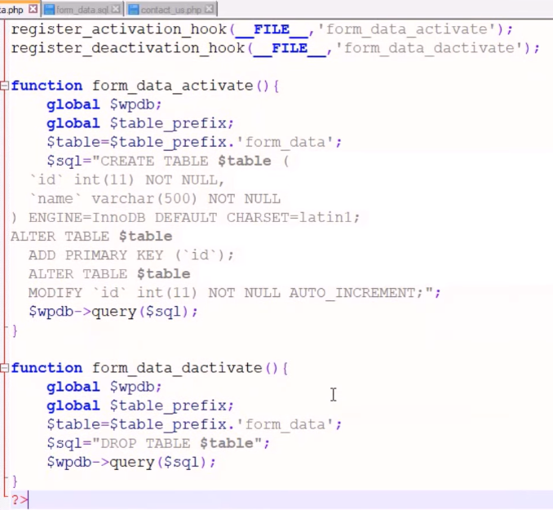

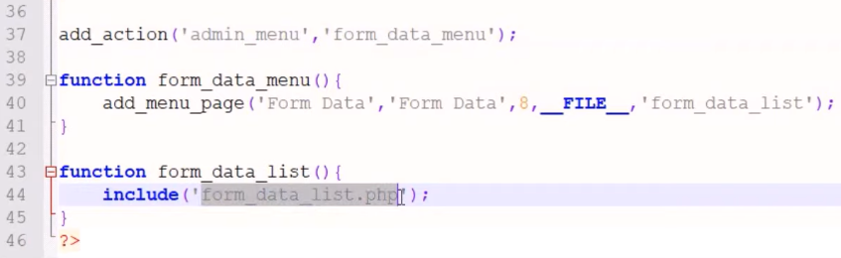

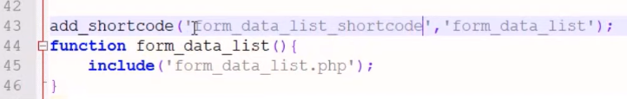

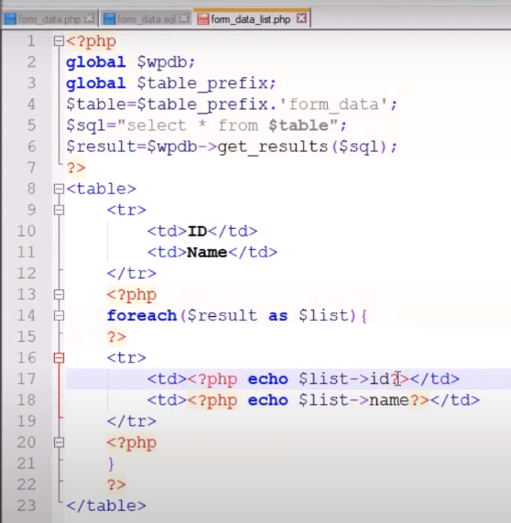

# [Display Posts from Specific Category On A WordPress Page](https://artisansweb.net/display-posts-specific-category-wordpress-page/)

<https://artisansweb.net/display-posts-specific-category-wordpress-page/>

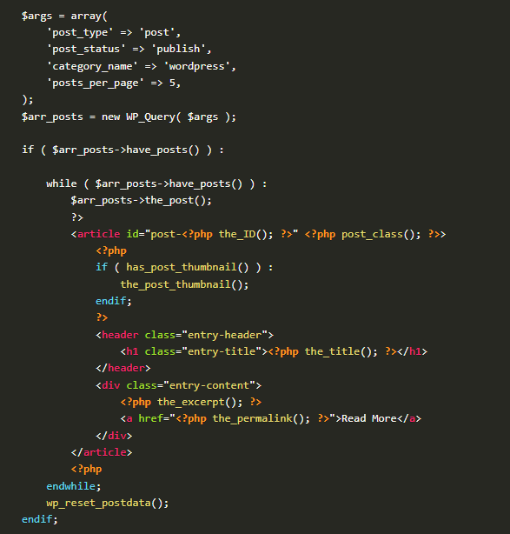

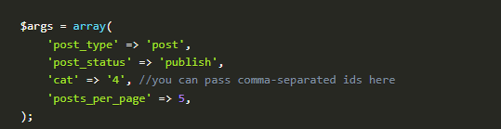

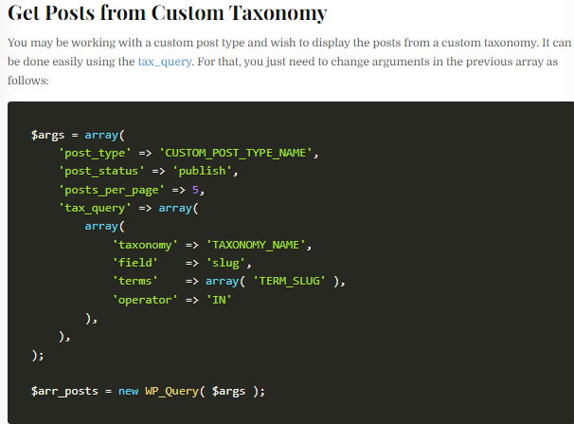

**template-category.php**

**<?php**

/**

* Template Name: Category Custom Page

*/

get_header(); **?>**

<div id="primary" class="content-area">

<main id="main" class="site-main" role="main">

**<?php**

$paged = (get_query_var( 'paged' )) ? get_query_var( 'paged' ) : 1;

$args = array(

'post_type' => 'post',

'post_status' => 'publish',

'category_name' => 'wordpress',

'posts_per_page' => 5,

'paged' => $paged,

);

$arr_posts = new WP_Query( $args );

if ( $arr_posts->have_posts() ) :

while ( $arr_posts->have_posts() ) :

$arr_posts->the_post();

**?>**

<article id="post-**<?php** the_ID(); **?>**" **<?php** post_class(); **?>**>

**<?php**

if ( has_post_thumbnail() ) :

the_post_thumbnail();

endif;

**?>**

<header class="entry-header">

<h1 class="entry-title">**<?php** the_title(); **?>**</h1>

</header>

<div class="entry-content">

**<?php** the_excerpt(); **?>**

<a href="**<?php** the_permalink(); **?>**">Read More</a>

</div>

</article>

**<?php**

endwhile;

wp_pagenavi(

array(

'query' => $arr_posts,

)

);

wp_reset_postdata();

endif;

**?>**

</main><!-- .site-main -->

</div><!-- .content-area -->

**<?php** get_footer(); **?>**

**Ddd**

**Increase WordPress File Upload Size Limit**

#### 1 – Using htaccess

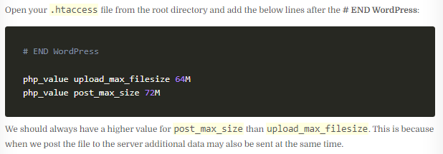

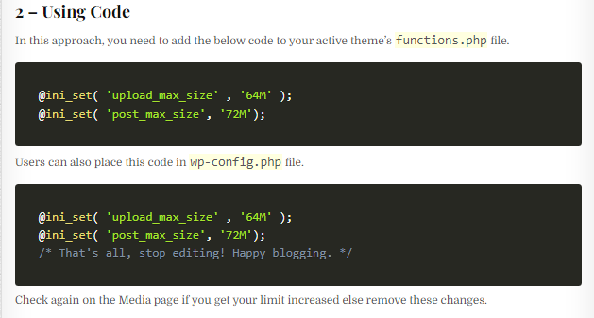

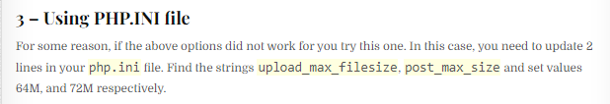

#### 4 – Using Web Hosting Tool

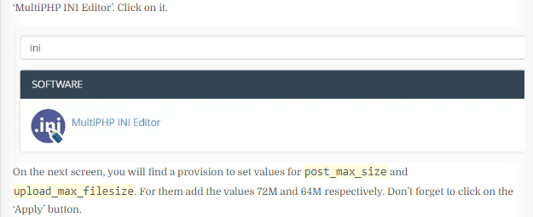

# [How to Add Image Field to Taxonomy](https://artisansweb.net/add-image-field-taxonomy-wordpress/) ACF Plugin

### Display Category Image On the Front End

The advanced custom fields plugin provides a method called get_field() to display the field values. To this function, you have to pass a field name(category_image) and category_TERM-ID. If you are dealing with a custom taxonomy then the second parameter would be term_TERM-ID. For more details, please refer to the plugin’s [documentation](https://www.advancedcustomfields.com/resources/adding-fields-taxonomy-term).

Let’s say you have uploaded an image for the category having ID 7. Then to display the image, the code will be as follows.

**<?php**

$term_id = 7;

$image = get_field('category_image', 'category_'. $term_id); //'category_image' is our field name

echo '<img src="'.$image['url'].'" alt="'.$image['alt'].'" />';

### Category Images

**<?php**

**if (have_posts()) :**

**while (have_posts()) : the_post();**

**// Get the current category ID**

**$category_id = get_the_category()[0]->cat_ID;**

**// Get the ACF category image**

**$category_image = get_field('category_image', 'category_' . $category_id);**

**// Display the category image**

**if (!empty($category_image)) {**

**echo '<img src="' . esc_url($category_image['url']) . '" alt="' . get_cat_name($category_id) . '">';**

**}**

**the_title();**

**the_excerpt();**

**endwhile;**

**endif;**

**?>**

# [How to Customize Comment Form](https://artisansweb.net/how-to-customize-comment-form-in-wordpress/)

[**https://artisansweb.net/how-to-customize-comment-form-in-wordpress/**](https://artisansweb.net/how-to-customize-comment-form-in-wordpress/)

**Add Field to Comment Form**

WordPress provides an action hook comment_form_after_fields using which we can add fields to the comment form.

Let’s add a mobile number using this action hook. Place the below code in the functions.php file.

add_action( 'comment_form_after_fields', 'additional_fields' );

function additional_fields() {

echo '<p class="comment-form-mobile-number">' .

'<label for="mobile-number">' . esc_html__( 'Mobile Number' ) . '<span class="required">*</span></label>' .

'<input id="mobile-number" name="mobile-number" type="text" size="30" tabindex="5" /></p>';

}

## [Example wp-config.php for Debugging](https://wordpress.org/documentation/article/debugging-in-wordpress/#example-wp-config-php-for-debugging)

// Enable WP_DEBUG mode

define( 'WP_DEBUG', true );

// Enable Debug logging to the /wp-content/debug.log file

define( 'WP_DEBUG_LOG', true );

// Disable display of errors and warnings

define( 'WP_DEBUG_DISPLAY', false );

@ini_set( 'display_errors', 0 );

// Use dev versions of core JS and CSS files (only needed if you are modifying these core files)

define( 'SCRIPT_DEBUG', true );

* [**7 Tips for Debugging Problems in WordPress**](https://www.hostinger.in/tutorials/debug-wordpress?ppc_campaign=google_search_generic_hosting_all&bidkw=defaultkeyword&lo=9144873&gclid=CjwKCAjwsKqoBhBPEiwALrrqiKMSkaJ9UpaGLBmI0IB2OremDjpR0MkFty_9AViSc40Dc2F7zs4iyBoC4U0QAvD_BwE#7_Tips_for_Debugging_Problems_in_WordPress)
  + [**1. Activate WP_DEBUG**](https://www.hostinger.in/tutorials/debug-wordpress?ppc_campaign=google_search_generic_hosting_all&bidkw=defaultkeyword&lo=9144873&gclid=CjwKCAjwsKqoBhBPEiwALrrqiKMSkaJ9UpaGLBmI0IB2OremDjpR0MkFty_9AViSc40Dc2F7zs4iyBoC4U0QAvD_BwE#1_Activate_WP_DEBUG)
  + [**2. Enable WPDP Error Reporting**](https://www.hostinger.in/tutorials/debug-wordpress?ppc_campaign=google_search_generic_hosting_all&bidkw=defaultkeyword&lo=9144873&gclid=CjwKCAjwsKqoBhBPEiwALrrqiKMSkaJ9UpaGLBmI0IB2OremDjpR0MkFty_9AViSc40Dc2F7zs4iyBoC4U0QAvD_BwE#2_Enable_WPDP_Error_Reporting)
  + [**3. Check Your Website’s Error Logs**](https://www.hostinger.in/tutorials/debug-wordpress?ppc_campaign=google_search_generic_hosting_all&bidkw=defaultkeyword&lo=9144873&gclid=CjwKCAjwsKqoBhBPEiwALrrqiKMSkaJ9UpaGLBmI0IB2OremDjpR0MkFty_9AViSc40Dc2F7zs4iyBoC4U0QAvD_BwE#3_Check_Your_Website%E2%80%99s_Error_Logs)
  + [**4. Use WordPress Staging Environment when Tweaking Your Code**](https://www.hostinger.in/tutorials/debug-wordpress?ppc_campaign=google_search_generic_hosting_all&bidkw=defaultkeyword&lo=9144873&gclid=CjwKCAjwsKqoBhBPEiwALrrqiKMSkaJ9UpaGLBmI0IB2OremDjpR0MkFty_9AViSc40Dc2F7zs4iyBoC4U0QAvD_BwE#4_Use_WordPress_Staging_Environment_when_Tweaking_Your_Code)
  + [**5. Enable SCRIPT_DEBUG**](https://www.hostinger.in/tutorials/debug-wordpress?ppc_campaign=google_search_generic_hosting_all&bidkw=defaultkeyword&lo=9144873&gclid=CjwKCAjwsKqoBhBPEiwALrrqiKMSkaJ9UpaGLBmI0IB2OremDjpR0MkFty_9AViSc40Dc2F7zs4iyBoC4U0QAvD_BwE#5_Enable_SCRIPT_DEBUG)
  + [**6. Detect PHP Errors**](https://www.hostinger.in/tutorials/debug-wordpress?ppc_campaign=google_search_generic_hosting_all&bidkw=defaultkeyword&lo=9144873&gclid=CjwKCAjwsKqoBhBPEiwALrrqiKMSkaJ9UpaGLBmI0IB2OremDjpR0MkFty_9AViSc40Dc2F7zs4iyBoC4U0QAvD_BwE#6_Detect_PHP_Errors)
  + [**7. Take Advantage of Some Debugging Tools**](https://www.hostinger.in/tutorials/debug-wordpress?ppc_campaign=google_search_generic_hosting_all&bidkw=defaultkeyword&lo=9144873&gclid=CjwKCAjwsKqoBhBPEiwALrrqiKMSkaJ9UpaGLBmI0IB2OremDjpR0MkFty_9AViSc40Dc2F7zs4iyBoC4U0QAvD_BwE#7_Take_Advantage_of_Some_Debugging_Tools)

**Create a Custom Search Form**

The get_search_form() function looks for a searchform.php file in your active theme’s directory. If this file does not exist then WordPress uses the default search form which is included in its core.

It means you should create a searchform.php file in your active theme’s directory. Doing so WordPress takes the search form from your theme instead of its core. In this file add your markup of the search form. In my case, the HTML is as follows.

<form id="searchform" method="get" action="<?php echo esc_url( home_url( '/' ) ); ?>">

<input type="text" class="search-field" name="s" placeholder="Search" value="<?php echo get_search_query(); ?>" />

<input type="submit" value="Search" />

</form>

Let’s say you have created custom post types book, magazine, ebook, and pdf for the above resources. Then, your hidden fields will be as follows.

<form id="searchform" method="get" action="<?php echo esc_url( home_url( '/' ) ); ?>">

<input type="text" class="search-field" name="s" placeholder="Search" value="<?php echo get_search_query(); ?>" />

<input type="hidden" name="post_type[]" value="book" />

<input type="hidden" name="post_type[]" value="magazine" />

<input type="hidden" name="post_type[]" value="ebook" />

<input type="hidden" name="post_type[]" value="pdf" />

<input type="submit" value="Search" />

</form>

**WP_Query Class**

### [Custom Query Loop](https://developer.wordpress.org/reference/classes/wp_query/#standard-loop-alternate)

**$args = array( 'post_type' => 'blog', 'posts_per_page' => 10 );**

**$loop = new WP_Query( $args );**

**while ( $loop->have_posts() ) : $loop->the_post();**

**the_title();**

**echo '<div class="entry-content">';**

**the_content();**

**echo '</div>';**

### endwhile

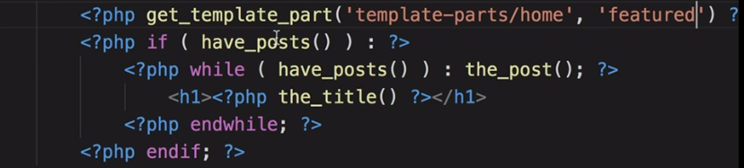

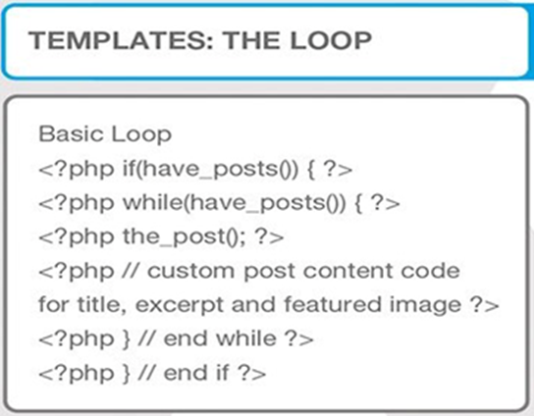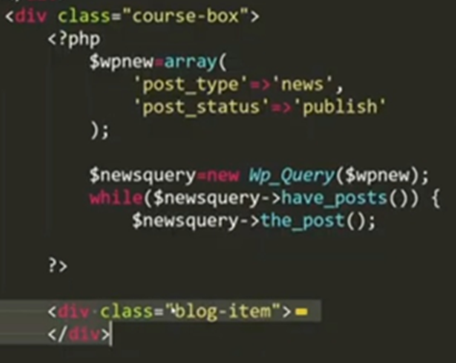

### [Standard Loop](https://developer.wordpress.org/reference/classes/wp_query/#standard-loop)

**<?php**

**$the_query = new WP_Query( $args );**

**if ( $the_query->have_posts() ) {**

**while ( $the_query->have_posts() ) {**

**$the_query->the_post();**

**echo '<li>' . esc_html( get_the_title() ) . '</li>';**

**}**

**} else {**

**esc_html_e( 'Sorry, no posts matched your criteria.' );**

**}**

**wp_reset_postdata();**

### [Standard Loop (Alternate)](https://developer.wordpress.org/reference/classes/wp_query/#standard-loop-alternate)

**<?php**

**$the_query = new WP_Query( $args ); ?>**

**<?php if ( $the_query->have_posts() ) : ?>**

**<!-- pagination here -->**

**<!-- the loop -->**

**<?php**

**while ( $the_query->have_posts() ) :**

**$the_query->the_post();**

**?>**

**<?php the_title( '<h2>', '</h2>' ); ?>**

**<?php endwhile; ?>**

**<!-- end of the loop -->**

**<!-- pagination here -->**

**<?php wp_reset_postdata(); ?>**

**<?php else : ?>**

**<p><?php esc_html_e( 'Sorry, no posts matched your criteria.' ); ?></p>**

**<?php endif; ?>**

### [Multiple Loops](https://developer.wordpress.org/reference/classes/wp_query/#multiple-loops)

**<?php**

**$query1 = new WP_Query( $args );**

**// The Loop**

**while ( $query1->have_posts() ) {**

**$query1->the_post();**

**echo '<li>' . get_the_title() . '</li>';**

**}**

/* Restore original Post Data

* NB: Because we are using new WP_Query we aren't stomping on the

* original $wp_query and it does not need to be reset with

* wp_reset_query(). We just need to set the post data back up with

* wp_reset_postdata().

*/

**wp_reset_postdata();**

**/* The 2nd Query (without global var) */**

**$query2 = new WP_Query( $args2 );**

**// The 2nd Loop**

**while ( $query2->have_posts() ) {**

**$query2->the_post();**

**echo '<li>' . get_the_title( $query2->post->ID ) . '</li>';**

**}**

**wp_reset_postdata();**

**?>**

**Query Sample**

**Refference**

[**https://developer.wordpress.org/reference/classes/wp_query/**](https://developer.wordpress.org/reference/classes/wp_query/)

### 1. [Category Parameters](https://developer.wordpress.org/reference/classes/wp_query/#category-parameters)

* **cat** (*int*) – use category id.
* **category_name** (*string*) – use category slug.
* **category__and** (*array*) – use category id.
* **category__in** (*array*) – use category id.
* **category__not_in** (*array*) – use category id.

**$query = new WP_Query( array( 'cat' => 4 ) )**

**$query = new WP_Query( array( 'category_name' => 'staff' ) )**

**$query = new WP_Query( array( 'cat' => '2,6,17,38' ) )**

**$query = new WP_Query( array( 'category_name' => 'staff,news' ) )**

**$query = new WP_Query( array( 'cat' => '-12,-34,-56' ) )**

**2. Author Parameters**

* **author** (*int*) – use author id.
* **author_name** (*string*) – use ‘user_nicename‘ – NOT name.
* **author__in** (*array*) – use author id (available since version 3.7).
* **author__not_in** (*array*) – use author id (available since version 3.7).

**$query = new WP_Query( array( 'author' => 123 ) );**

**$query = new WP_Query( array( 'author' => '2,6,17,38' ) );**

**$query = new WP_Query( array( 'author' => -12 ) );**

### 3. [Tag Parameters](https://developer.wordpress.org/reference/classes/wp_query/#category-parameters)

* **tag** (*string*) – use tag slug.
* **tag_id** (*int*) – use tag id.
* **tag__and** (*array*) – use tag ids.
* **tag__in** (*array*) – use tag ids.

**$query = new WP_Query( array( 'tag' => 'cooking' ) )**

**$query = new WP_Query( array( 'tag_id' => 13 ) )**

**$query = new WP_Query( array( 'tag' => 'bread+baking+recipe' ) )**

**$query = new WP_Query( array( 'tag__in' => array( 37, 47 ) ) );**

### 3. [Taxonomy Parameters](https://developer.wordpress.org/reference/classes/wp_query/#category-parameters)

### 

**Sample 1.**

**$args = array(**

**'post_type' => 'post',**

**'tax_query' => array(**

**'relation' => 'AND',**

**array(**

**'taxonomy' => 'movie_genre',**

**'field' => 'slug',**

**'terms' => array( 'action', 'comedy' ),**

**),**

**array(**

**'taxonomy' => 'actor',**

**'field' => 'term_id',**

**'terms' => array( 103, 115, 206 ),**

**'operator' => 'NOT IN',**

**),**

**),**

**);**

**$query = new WP_Query( $args );**

**Sample 2**

**$args = array(**

**'post_type' => 'post',**

**'tax_query' => array(**

**'relation' => 'OR',**

**array(**

**'taxonomy' => 'category',**

**'field' => 'slug',**

**'terms' => array( 'quotes' ),**

**),**

**array(**

**'taxonomy' => 'post_format',**

**'field' => 'slug',**

**'terms' => array( 'post-format-quote' ),**

**),**

**),**

**);**

**$query = new WP_Query( $args );**

### 4.[Post Parameters](https://developer.wordpress.org/reference/classes/wp_query/#category-parameters)

**$query = new WP_Query( array( 'post_type' => 'page' ) );**

**$query = new WP_Query( array( 'post_type' => 'any' ) );**

**$args = array(**

**'post_type' => array( 'post', 'page', 'movie', 'book' )**

**);**

**$query = new WP_Query( $args );**

### 5.Post Status Parameter

* **‘publish‘ – a published post or page.**
* **‘pending‘ – post is pending review.**
* **‘draft‘ – a post in draft status.**
* **‘auto-draft‘ – a newly created post, with no content.**
* **‘future‘ – a post to publish in the future.**
* **‘private‘ – not visible to users who are not logged in.**
* **‘inherit‘ – a revision. see**[**get_children()**](https://developer.wordpress.org/reference/functions/get_children/)**.**
* **‘trash‘ – post is in trashbin (available since version 2.9).**
* **‘any‘ – retrieves any status except for ‘inherit’, ‘trash’ and ‘auto-draft’. Custom post statuses with ‘exclude_from_search’ set to true are also excluded.**

### 5.Comment Parameter

**$args = array(**

**'post_type' => 'post',**

**'comment_count' => 20,**

**);**

**$args = array(**

**'post_type' => 'post',**

**'comment_count' => array(**

**'value' => 25,**

**'compare' => '>=',**

**)**

**);**

### Pagination Parameter

**$query = new WP_Query( array( 'posts_per_page' => 3 ) );**

**$query = new WP_Query( array( 'posts_per_page' => -1 ) );**

**$query = new WP_Query( array( 'nopaging' => true ) );**

**Order & Orderby Parameters**

**order (string | array)**

**orderby (string | array)**

**‘none‘ – No order (available since version 2.8).**

**‘ID‘ – Order by post id. Note the capitalization.**

**‘author‘ – Order by author.**

**‘title‘ – Order by title.**

**‘name‘ – Order by post name (post slug).**

**‘type‘ – Order by post type (available since version 4.0).**

**‘date‘ – Order by date.**

**‘modified‘ – Order by last modified date.**

**‘parent‘ – Order by post/page parent id.**

**‘rand‘ – Random order.**

**‘comment_count‘ – Order by number of comments**

**$args = array(**

**'orderby' => 'title',**

**'order' => 'DESC',**

**);**

**$query = new WP_Query( $args );**

**$args = array(**

**'orderby' => 'menu_order title',**

**'order' => 'DESC',**

**);**

**$query = new WP_Query( $args );**

**$args = array(**

**'orderby' => array( 'meta_value_num' => 'DESC', 'title' => 'ASC' ),**

**'meta_key' => 'age'**

**);**

**$query = new WP_Query( $args );**

**MetaQuery**

$args = array(

    'post_type' => 'your_post_type', // Replace with the name of your custom post type

    'posts_per_page' => -1, // Retrieve all posts (you can adjust this as needed)

    'meta_key' => 'price', // Name of the custom field

    'meta_value' => 100, // Replace with your desired value

    'meta_compare' => '>', // Comparison operator (e.g., '>', '<', '>=', '<=')

    'orderby' => 'date', // Order by date (you can change this to other fields)

    'order' => 'DESC', // Descending order (you can use 'ASC' for ascending)

);

$custom_query = new WP_Query($args);

if ($custom_query->have_posts()) :

    while ($custom_query->have_posts()) : $custom_query->the_post();

        the_title();

        the_content();

        // Output the custom field value

        $price = get_post_meta(get_the_ID(), 'price', true);

        echo 'Price: $' . esc_html($price);

    endwhile;

    wp_reset_postdata();

else :

       echo 'No posts found.';

endif;

### [Custom Field (post meta) Parameters](https://developer.wordpress.org/reference/classes/wp_query/#custom-field-post-meta-parameters)

* **meta_key** (*string*) – Custom field key.
* **meta_value** (*string*) – Custom field value.
* **meta_value_num** (*number*) – Custom field value.
* **meta_compare** (*string*) – Operator to test the ‘meta_value‘. Possible values are ‘=’, ‘!=’, ‘>’, ‘>=’, ‘<‘, ‘<=’, ‘LIKE’, ‘NOT LIKE’, ‘IN’, ‘NOT IN’, ‘BETWEEN’, ‘NOT BETWEEN’, ‘NOT EXISTS’, ‘REGEXP’, ‘NOT REGEXP’ or ‘RLIKE’. Default value is ‘=’.
* **meta_query** (*array*) – Custom field parameters

**$args = array(**

**'post_type' => 'my_custom_post_type',**

**'meta_key' => 'age',**

**'orderby' => 'meta_value_num',**

**'order' => 'ASC',**

**'meta_query' => array(**

**array(**

**'key' => 'age',**

**'value' => array( 3, 4 ),**

**'compare' => 'IN',**

**),**

**),**

**);**

**$query = new WP_Query( $args );**

**$q = new WP_Query(**

**array(**

**'meta_query' => array(**

**'relation' => 'AND',**

**'state_clause' => array(**

**'key' => 'state',**

**'value' => 'Wisconsin',**

**),**

**'city_clause' => array(**

**'key' => 'city',**

**'compare' => 'EXISTS',**

**),**

**),**

**'orderby' => array(**

**'city_clause' => 'ASC',**

**'state_clause' => 'DESC',**

**),**

**) );**

**$query = new WP_Query( array( 'meta_key' => 'color' ) );**

**$query = new WP_Query( array( 'meta_value' => 'blue' ) );**

**$args = array(**

**'meta_value' => 'blue',**

**'post_type' => 'page'**

**);**

**$query = new WP_Query( $args );**

**$args = array(**

**'meta_key' => 'color',**

**'meta_value' => 'blue',**

**'meta_compare' => '!='**

**);**

**$query = new WP_Query( $args );**

**$args = array(**

**'post_type' => 'event',**

**'meta_key' => 'event_date',**

**'meta_value' => date( "Ymd" ), // change to how "event date" is stored**

**'meta_compare' => '>',**

**);**

**$query = new WP_Query( $args );**

**$args = array(**

**'meta_key' => 'price',**

**'meta_value' => '22',**

**'meta_compare' => '<=',**

**'post_type' => 'product'**

**);**

**$query = new WP_Query( $args );**

**$args = array(**

**'post_type' => 'product',**

**'meta_query' => array(**

**array(**

**'key' => 'color',**

**'value' => 'blue',**

**'compare' => 'NOT LIKE',**

**),**

**),**

**);**

**$query = new WP_Query( $args );**

### [Permission Parameters](https://developer.wordpress.org/reference/classes/wp_query/#permission-parameters)

**$args = array(**

**'post_status' => array( 'publish', 'private' ),**

**'perm' => 'readable',**

**);**

**$query = new WP_Query( $args** );

### [Mime Type Parameters](https://developer.wordpress.org/reference/classes/wp_query/#mime-type-parameters)

**$args = array(**

**'post_type' => 'attachment',**

**'post_status' => 'inherit',**

**'post_mime_type' => 'image/gif',**

**);**

**$query = new WP_Query( $args );**

**$unsupported_mimes = array( 'image/jpeg', 'image/gif', 'image/png', 'image/bmp', 'image/tiff', 'image/x-icon' );**

**$all_mimes = get_allowed_mime_types();**

**$accepted_mimes = array_diff( $all_mimes, $unsupported_mimes );**

**$args = array(**

**'post_type' => 'attachment',**

**'post_status' => 'inherit',**

**'post_mime_type' => $accepted_mimes,**

**);**

**$query = new WP_Query( $query_args );**

### [Caching Parameters](https://developer.wordpress.org/reference/classes/wp_query/#caching-parameters)

* **cache_results** (*boolean*) – Post information cache.
* **update_post_meta_cache** (*boolean*) – Post meta information cache.
* **update_post_term_cache** (*boolean*) – Post term information cache.

**$args = array(**

**'posts_per_page' => 50,**

**'cache_results' => false**

**);**

**$query = new WP_Query( $args );**

**$args = array(**

**'posts_per_page' => 50,**

**'update_post_meta_cache' => false**

**);**

**$query = new WP_Query( $args );**

### [Return Fields Parameter](https://developer.wordpress.org/reference/classes/wp_query/#return-fields-parameter)

* **fields** (*string*) – Which fields to return. There are three options:
  + **'all'** – Return all fields (default).
  + **'ids'** – Return an array of post IDs.
  + **'id=>parent'** – Return an array of stdClass objects with ID and post_parent properties.

Passing anything else will return all fields (default) – an array of post objects.

## [Methods](https://developer.wordpress.org/reference/classes/wp_query/#methods)

* [__call](https://developer.wordpress.org/reference/classes/wp_query/__call/) — Makes private/protected methods readable for backward compatibility.
* [__construct](https://developer.wordpress.org/reference/classes/wp_query/__construct/) — Constructor.
* [__get](https://developer.wordpress.org/reference/classes/wp_query/__get/) — Makes private properties readable for backward compatibility.
* [__isset](https://developer.wordpress.org/reference/classes/wp_query/__isset/) — Makes private properties checkable for backward compatibility.
* [fill_query_vars](https://developer.wordpress.org/reference/classes/wp_query/fill_query_vars/) — Fills in the query variables, which do not exist within the parameter.
* [generate_cache_key](https://developer.wordpress.org/reference/classes/wp_query/generate_cache_key/) — Generates cache key.
* [generate_postdata](https://developer.wordpress.org/reference/classes/wp_query/generate_postdata/) — Generates post data.
* [get](https://developer.wordpress.org/reference/classes/wp_query/get/) — Retrieves the value of a query variable.
* [get_posts](https://developer.wordpress.org/reference/classes/wp_query/get_posts/) — Retrieves an array of posts based on query variables.
* [get_queried_object](https://developer.wordpress.org/reference/classes/wp_query/get_queried_object/) — Retrieves the currently queried object.
* [get_queried_object_id](https://developer.wordpress.org/reference/classes/wp_query/get_queried_object_id/) — Retrieves the ID of the currently queried object.
* [get_search_stopwords](https://developer.wordpress.org/reference/classes/wp_query/get_search_stopwords/) — Retrieves stopwords used when parsing search terms.
* [have_comments](https://developer.wordpress.org/reference/classes/wp_query/have_comments/) — Determines whether there are more comments available.
* [have_posts](https://developer.wordpress.org/reference/classes/wp_query/have_posts/) — Determines whether there are more posts available in the loop.
* [init](https://developer.wordpress.org/reference/classes/wp_query/init/) — Initiates object properties and sets default values.
* [init_query_flags](https://developer.wordpress.org/reference/classes/wp_query/init_query_flags/) — Resets query flags to false.
* [is_404](https://developer.wordpress.org/reference/classes/wp_query/is_404/) — Determines whether the query is a 404 (returns no results).
* [is_archive](https://developer.wordpress.org/reference/classes/wp_query/is_archive/) — Determines whether the query is for an existing archive page.
* [is_attachment](https://developer.wordpress.org/reference/classes/wp_query/is_attachment/) — Determines whether the query is for an existing attachment page.
* [is_author](https://developer.wordpress.org/reference/classes/wp_query/is_author/) — Determines whether the query is for an existing author archive page.
* [is_category](https://developer.wordpress.org/reference/classes/wp_query/is_category/) — Determines whether the query is for an existing category archive page.
* [is_comment_feed](https://developer.wordpress.org/reference/classes/wp_query/is_comment_feed/) — Determines whether the query is for a comments feed.
* [is_comments_popup](https://developer.wordpress.org/reference/classes/wp_query/is_comments_popup/) — Determines whether the current URL is within the comments popup window. — *deprecated*
* [is_date](https://developer.wordpress.org/reference/classes/wp_query/is_date/) — Determines whether the query is for an existing date archive.
* [is_day](https://developer.wordpress.org/reference/classes/wp_query/is_day/) — Determines whether the query is for an existing day archive.
* [is_embed](https://developer.wordpress.org/reference/classes/wp_query/is_embed/) — Determines whether the query is for an embedded post.
* [is_favicon](https://developer.wordpress.org/reference/classes/wp_query/is_favicon/) — Determines whether the query is for the favicon.ico file.
* [is_feed](https://developer.wordpress.org/reference/classes/wp_query/is_feed/) — Determines whether the query is for a feed.
* [is_front_page](https://developer.wordpress.org/reference/classes/wp_query/is_front_page/) — Determines whether the query is for the front page of the site.
* [is_home](https://developer.wordpress.org/reference/classes/wp_query/is_home/) — Determines whether the query is for the blog homepage.
* [is_main_query](https://developer.wordpress.org/reference/classes/wp_query/is_main_query/) — Determines whether the query is the main query.
* [is_month](https://developer.wordpress.org/reference/classes/wp_query/is_month/) — Determines whether the query is for an existing month archive.
* [is_page](https://developer.wordpress.org/reference/classes/wp_query/is_page/) — Determines whether the query is for an existing single page.
* [is_paged](https://developer.wordpress.org/reference/classes/wp_query/is_paged/) — Determines whether the query is for a paged result and not for the first page.
* [is_post_type_archive](https://developer.wordpress.org/reference/classes/wp_query/is_post_type_archive/) — Determines whether the query is for an existing post type archive page.
* [is_preview](https://developer.wordpress.org/reference/classes/wp_query/is_preview/) — Determines whether the query is for a post or page preview.
* [is_privacy_policy](https://developer.wordpress.org/reference/classes/wp_query/is_privacy_policy/) — Determines whether the query is for the Privacy Policy page.
* [is_robots](https://developer.wordpress.org/reference/classes/wp_query/is_robots/) — Determines whether the query is for the robots.txt file.
* [is_search](https://developer.wordpress.org/reference/classes/wp_query/is_search/) — Determines whether the query is for a search.
* [is_single](https://developer.wordpress.org/reference/classes/wp_query/is_single/) — Determines whether the query is for an existing single post.
* [is_singular](https://developer.wordpress.org/reference/classes/wp_query/is_singular/) — Determines whether the query is for an existing single post of any post type (post, attachment, page, custom post types).
* [is_tag](https://developer.wordpress.org/reference/classes/wp_query/is_tag/) — Determines whether the query is for an existing tag archive page.
* [is_tax](https://developer.wordpress.org/reference/classes/wp_query/is_tax/) — Determines whether the query is for an existing custom taxonomy archive page.
* [is_time](https://developer.wordpress.org/reference/classes/wp_query/is_time/) — Determines whether the query is for a specific time.
* [is_trackback](https://developer.wordpress.org/reference/classes/wp_query/is_trackback/) — Determines whether the query is for a trackback endpoint call.
* [is_year](https://developer.wordpress.org/reference/classes/wp_query/is_year/) — Determines whether the query is for an existing year archive.
* [lazyload_comment_meta](https://developer.wordpress.org/reference/classes/wp_query/lazyload_comment_meta/) — Lazyloads comment meta for comments in the loop. — *deprecated*
* [lazyload_term_meta](https://developer.wordpress.org/reference/classes/wp_query/lazyload_term_meta/) — Lazyloads term meta for posts in the loop. — *deprecated*
* [next_comment](https://developer.wordpress.org/reference/classes/wp_query/next_comment/) — Iterates current comment index and returns WP_Comment object.
* [next_post](https://developer.wordpress.org/reference/classes/wp_query/next_post/) — Sets up the next post and iterate current post index.
* [parse_order](https://developer.wordpress.org/reference/classes/wp_query/parse_order/) — Parse an 'order' query variable and cast it to ASC or DESC as necessary.
* [parse_orderby](https://developer.wordpress.org/reference/classes/wp_query/parse_orderby/) — Converts the given orderby alias (if allowed) to a properly-prefixed value.
* [parse_query](https://developer.wordpress.org/reference/classes/wp_query/parse_query/) — Parses a query string and sets query type booleans.
* [parse_query_vars](https://developer.wordpress.org/reference/classes/wp_query/parse_query_vars/) — Reparses the query vars.
* [parse_search](https://developer.wordpress.org/reference/classes/wp_query/parse_search/) — Generates SQL for the WHERE clause based on passed search terms.
* [parse_search_order](https://developer.wordpress.org/reference/classes/wp_query/parse_search_order/) — Generates SQL for the ORDER BY condition based on passed search terms.
* [parse_search_terms](https://developer.wordpress.org/reference/classes/wp_query/parse_search_terms/) — Checks if the terms are suitable for searching.
* [parse_tax_query](https://developer.wordpress.org/reference/classes/wp_query/parse_tax_query/) — Parses various taxonomy related query vars.
* [query](https://developer.wordpress.org/reference/classes/wp_query/query/) — Sets up the WordPress query by parsing query string.
* [reset_postdata](https://developer.wordpress.org/reference/classes/wp_query/reset_postdata/) — After looping through a nested query, this function restores the $post global to the current post in this query.
* [rewind_comments](https://developer.wordpress.org/reference/classes/wp_query/rewind_comments/) — Rewinds the comments, resets the comment index and comment to first.
* [rewind_posts](https://developer.wordpress.org/reference/classes/wp_query/rewind_posts/) — Rewinds the posts and resets post index.
* [set](https://developer.wordpress.org/reference/classes/wp_query/set/) — Sets the value of a query variable.
* [set_404](https://developer.wordpress.org/reference/classes/wp_query/set_404/) — Sets the 404 property and saves whether query is feed.
* [set_found_posts](https://developer.wordpress.org/reference/classes/wp_query/set_found_posts/) — Sets up the amount of found posts and the number of pages (if limit clause was used) for the current query.
* [setup_postdata](https://developer.wordpress.org/reference/classes/wp_query/setup_postdata/) — Sets up global post data.
* [the_comment](https://developer.wordpress.org/reference/classes/wp_query/the_comment/) — Sets up the current comment.
* [the_post](https://developer.wordpress.org/reference/classes/wp_query/the_post/) — Sets up the current post.

### Creating Custom field

### 

### 

**Opps Method custom field**

Refference

<https://developer.wordpress.org/plugins/metadata/custom-meta-boxes/>

**abstract class WPOrg_Meta_Box {**

**/\*\***

**\* Set up and add the meta box.**

**\*/**

**public static function add() {**

**$screens = [ 'post', 'wporg_cpt' ];**

**foreach ( $screens as $screen ) {**

**add_meta_box(**

**'wporg_box_id',          // Unique ID**

**'Custom Meta Box Title', // Box title**

**[ self::class, 'html' ],   // Content callback, must be of type callable**

**$screen                  // Post type**

**);**

**}**

**}**

**/\*\***

**\* Save the meta box selections.**

**\***

**\* @param int $post_id  The post ID.**

**\*/**

**public static function save( int $post_id ) {**

**if ( array_key_exists( 'wporg_field', $_POST ) ) {**

**update_post_meta(**

**$post_id,**

**'_wporg_meta_key',**

**$_POST['wporg_field']**

**);**

**}**

**}**

**/\*\***

**\* Display the meta box HTML to the user.**

**\***

**\* @param WP_Post $post   Post object.**

**\*/**

**public static function html( $post ) {**

**$value = get_post_meta( $post->ID, '_wporg_meta_key', true );**

**?>**

**<label for="wporg_field">Description for this field</label>**

**<select name="wporg_field" id="wporg_field" class="postbox">**

**<option value="">Select something...</option>**

**<option value="something" <?php selected( $value, 'something' ); ?>>Something</option>**

**<option value="else" <?php selected( $value, 'else' ); ?>>Else</option>**

**</select>**

**<?php**

**}**

**}**

**add_action( 'add_meta_boxes', [ 'WPOrg_Meta_Box', 'add' ] );**

**add_action( 'save_post', [ 'WPOrg_Meta_Box', 'save' ] );**

**Method 2**

**//adding metabox**

**function wporg_add_custom_box() {**

**$screens = [ 'post', 'wporg_cpt' ];**

**foreach ( $screens as $screen ) {**

**add_meta_box(**

**'wporg_box_id',                 // Unique ID**

**'Custom Meta Box Title',      // Box title**

**'wporg_custom_box_html',  // Content callback, must be of type callable**

**$screen                            // Post type**

**);**

**}**

**}**

**add_action( 'add_meta_boxes', 'wporg_add_custom_box' );**

**function wporg_custom_box_html( $post ) {**

**?>**

**<label for="wporg_field">Description for this field</label>**

**<select name="wporg_field" id="wporg_field" class="postbox">**

**<option value="">Select something...</option>**

**<option value="something">Something</option>**

**<option value="else">Else</option>**

**</select>**

**<?php**

**}**

**//Adding metadata**

**function wporg_custom_box_html( $post ) {**

**$value = get_post_meta( $post->ID, '_wporg_meta_key', true );**

**?>**

**<label for="wporg_field">Description for this field</label>**

**<select name="wporg_field" id="wporg_field" class="postbox">**

**<option value="">Select something...</option>**

**<option value="something" <?php selected( $value, 'something' ); ?>>Something</option>**

**<option value="else" <?php selected( $value, 'else' ); ?>>Else</option>**

**</select>**

**<?php**

**}**

**//Saving metadata**

**function wporg_save_postdata( $post_id ) {**

**if ( array_key_exists( 'wporg_field', $_POST ) ) {**

**update_post_meta(**

**$post_id,**

**'_wporg_meta_key',**

**$_POST['wporg_field']**

**);**

**}**

**}**

**add_action( 'save_post', 'wporg_save_postdata' );**

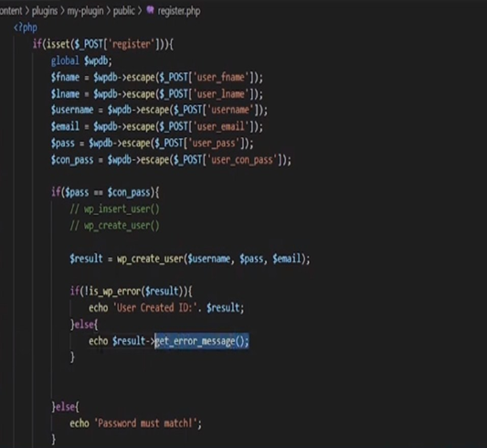 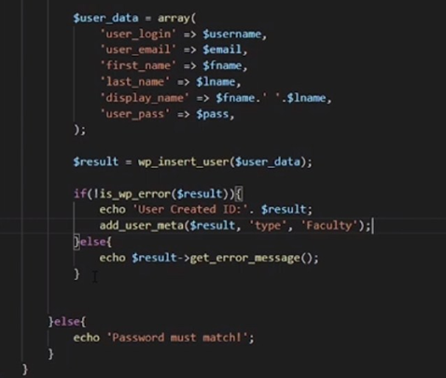

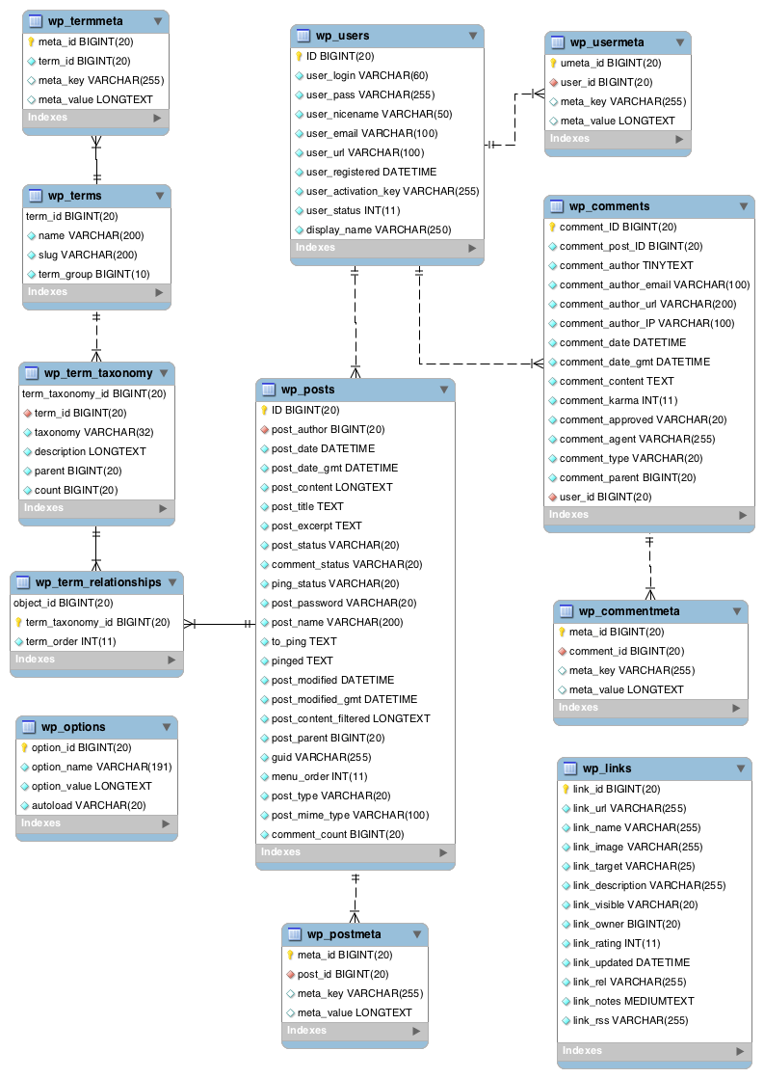

**How to create a custom plugin for your shortcode:**

**<?php**

**/\***

**Plugin Name: Custom Shortcode Plugin**

**Description: A custom shortcode for demonstration purposes.**

**Version: 1.0**

**\*/**

**// Define the shortcode function**

**function custom_shortcode_function($atts) {**

**// Parse and sanitize shortcode attributes**

**$atts = shortcode_atts(**

**array(**

**'parameter1' => 'default_value1',**

**'parameter2' => 'default_value2',**

**),**

**$atts**

**);**

**// Extract parameters**

**$parameter1 = $atts['parameter1'];**

**$parameter2 = $atts['parameter2'];**

**// Your shortcode logic here**

**$output = "Parameter 1: $parameter1<br>";**

**$output .= "Parameter 2: $parameter2";**

**return $output;**

**}**

**// Register the shortcode**

**add_shortcode('custom_shortcode', 'custom_shortcode_function');**

[custom_shortcode parameter1="value1" parameter2="value2"]

<p>This is some content before the custom shortcode.</p>

**[custom_shortcode parameter1="Hello" parameter2="World"]**

<p>This is some content after the custom shortcode.</p

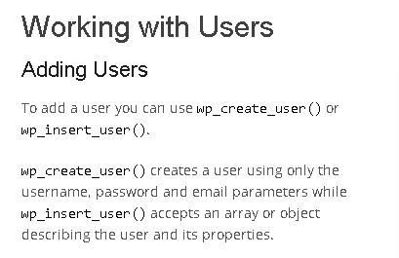 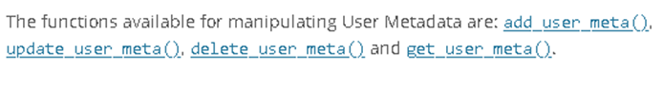

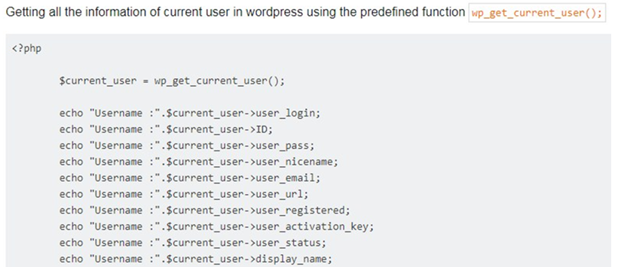

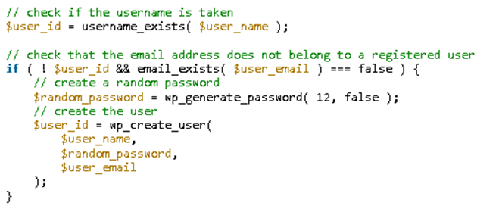

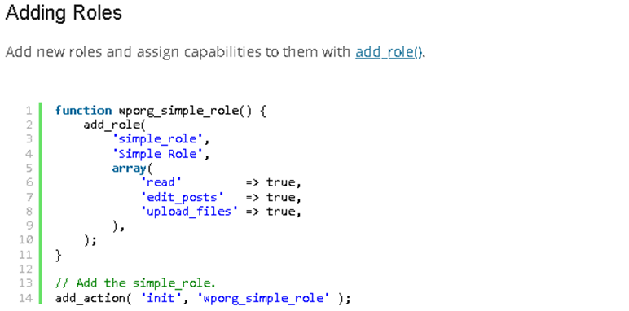

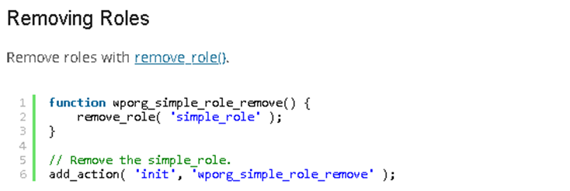

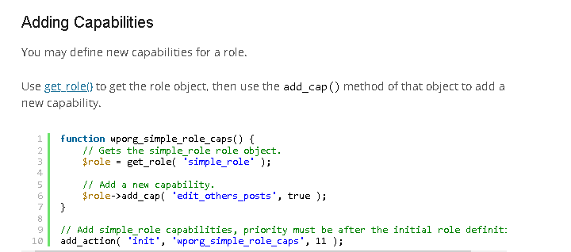

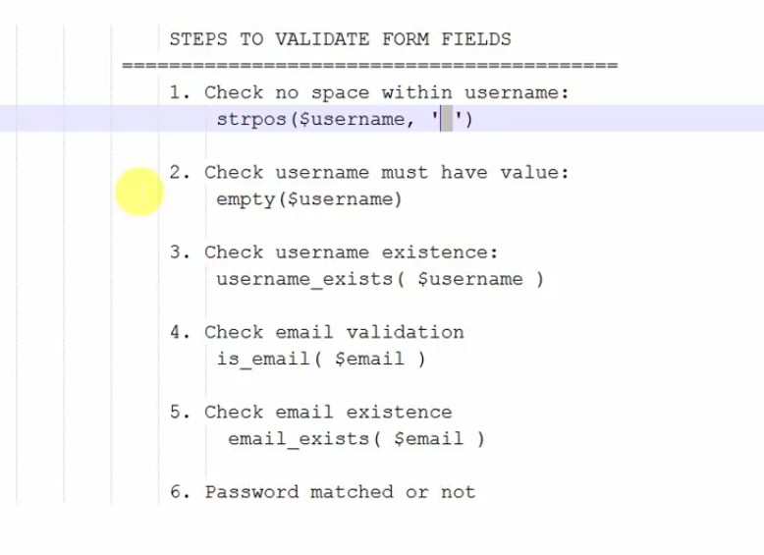

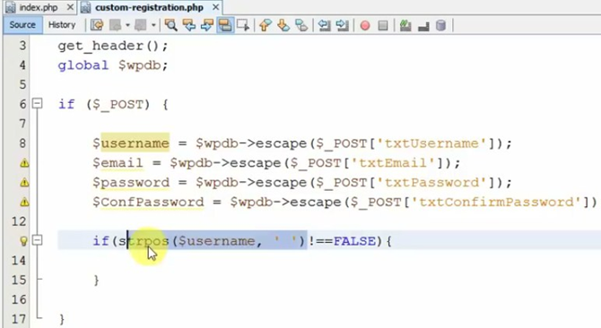

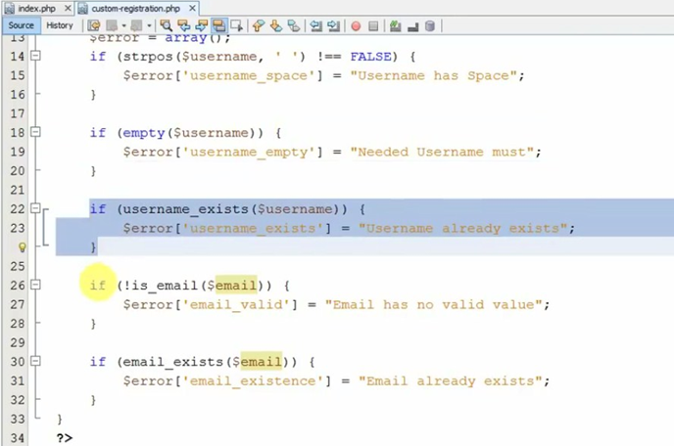

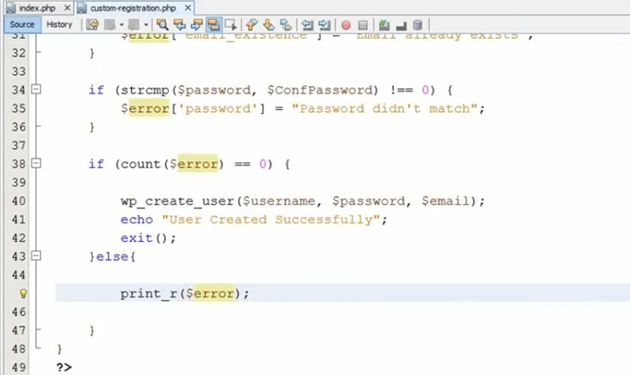

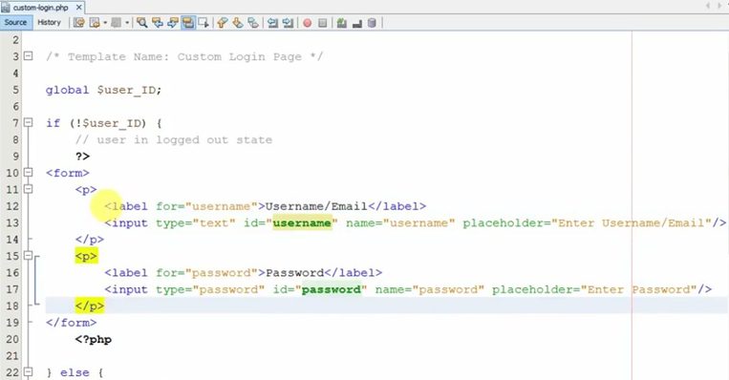

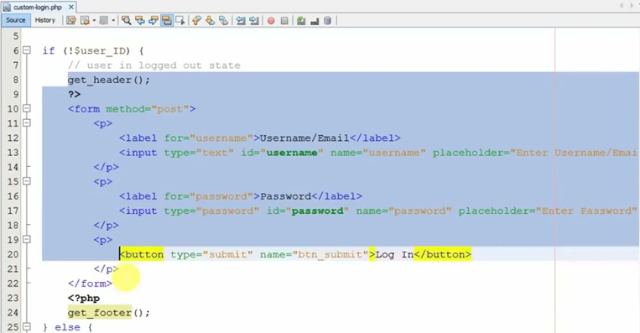

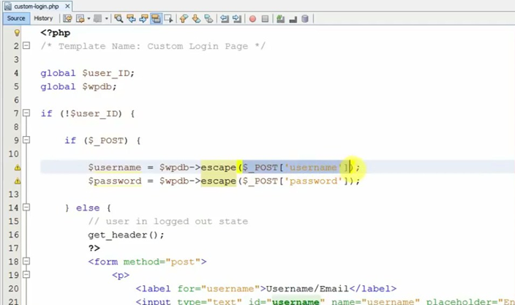

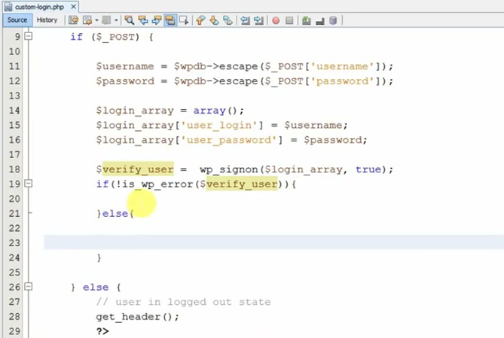

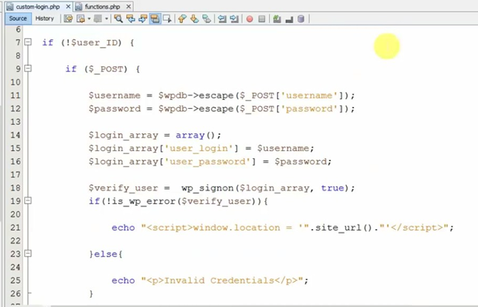

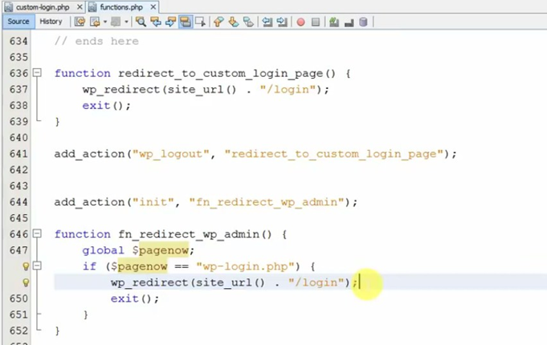

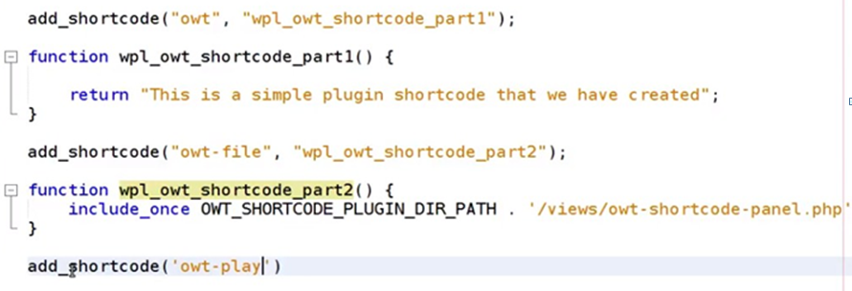

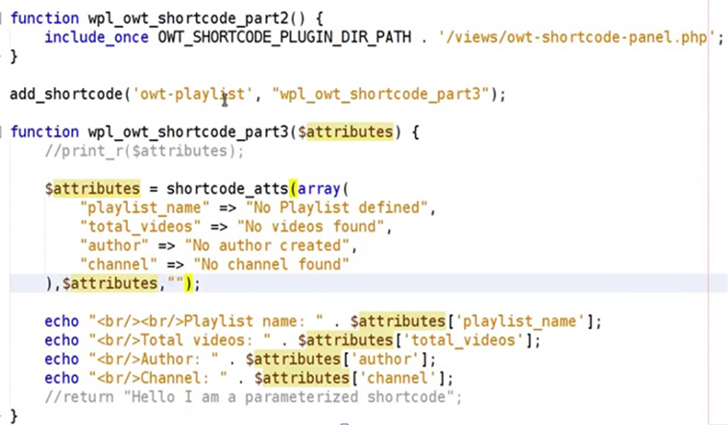

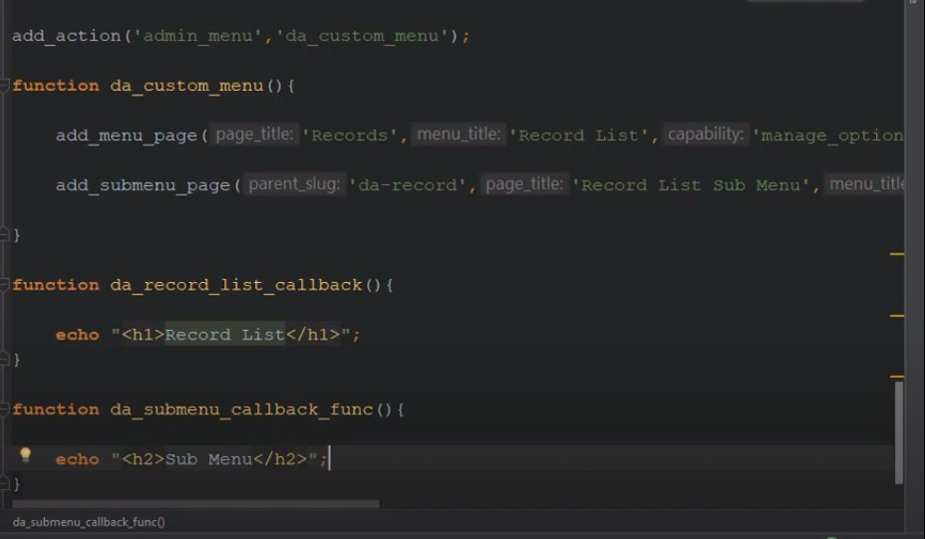

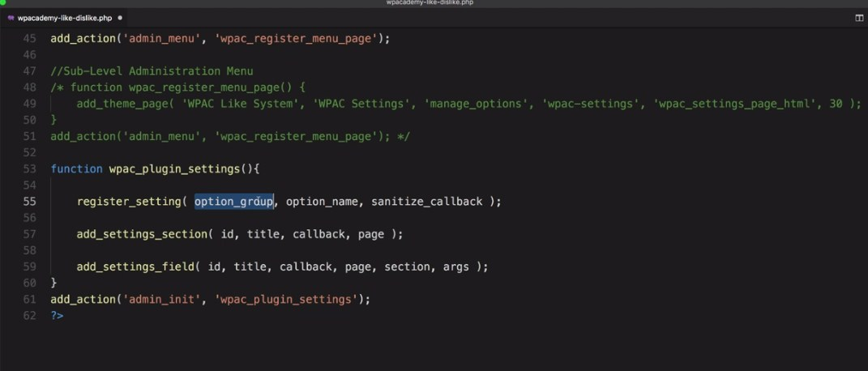

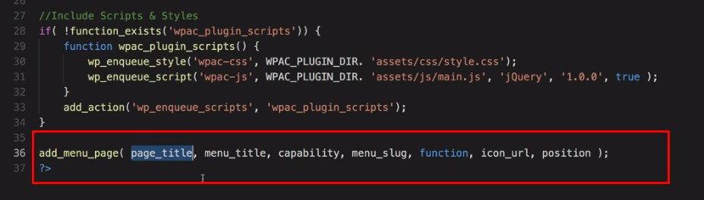

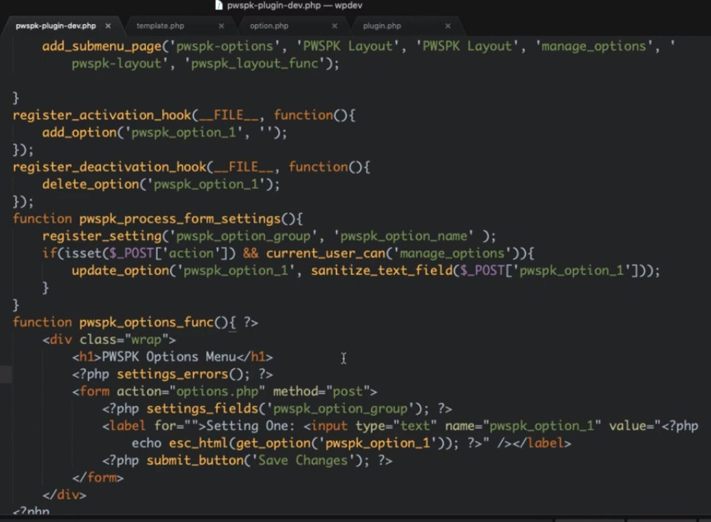

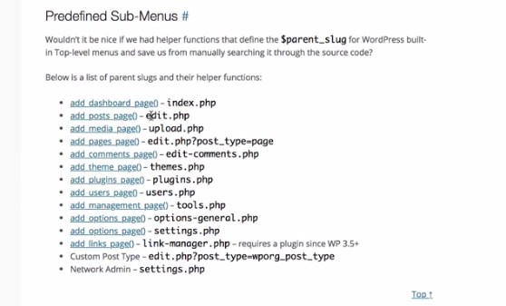

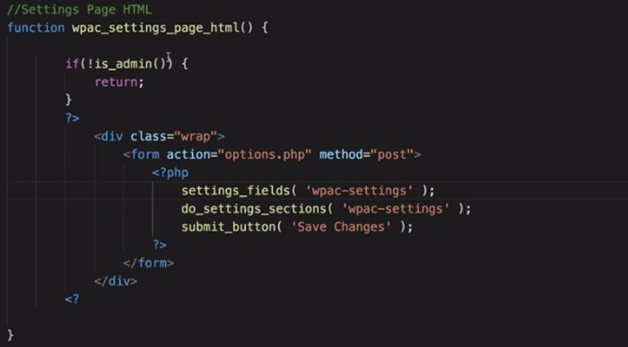

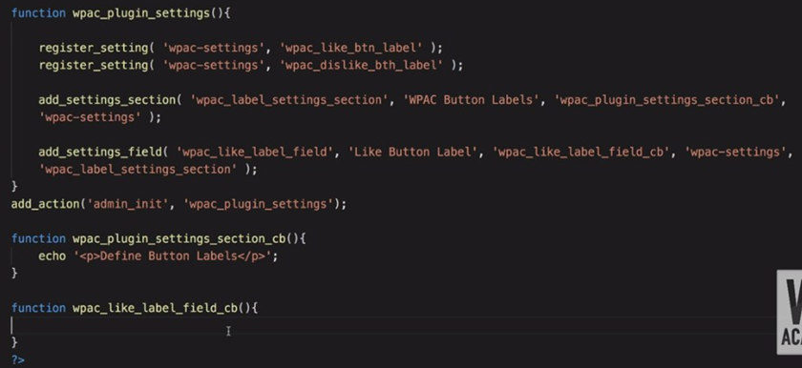

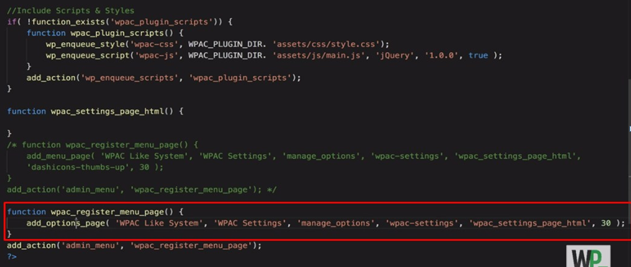

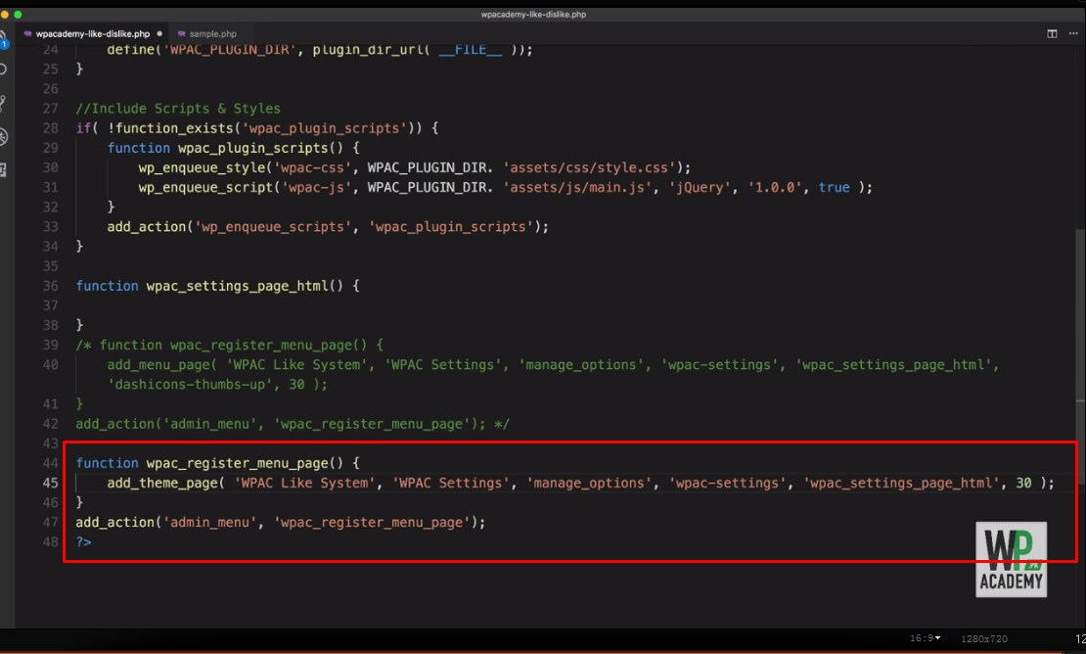

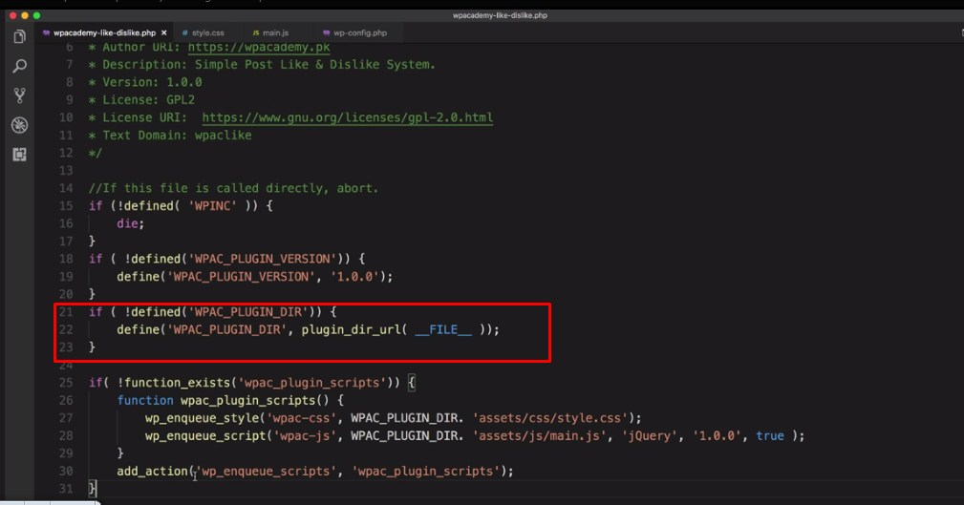

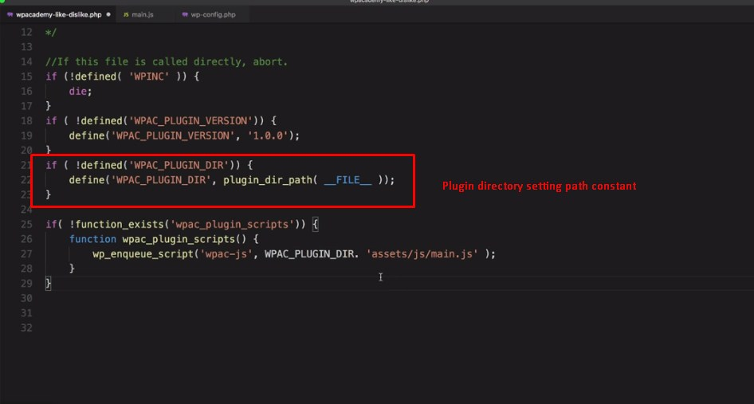

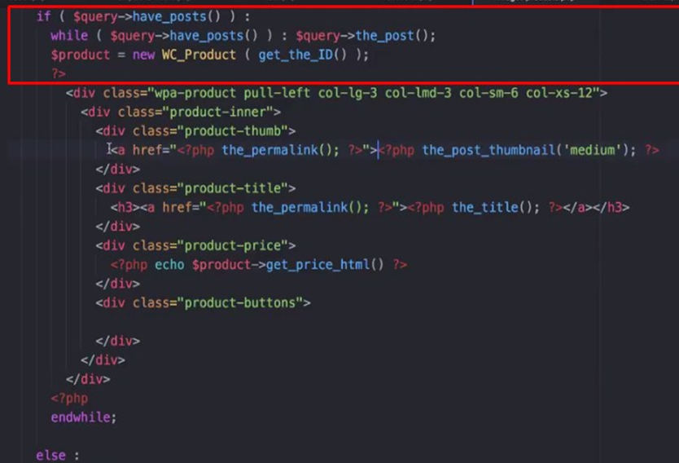

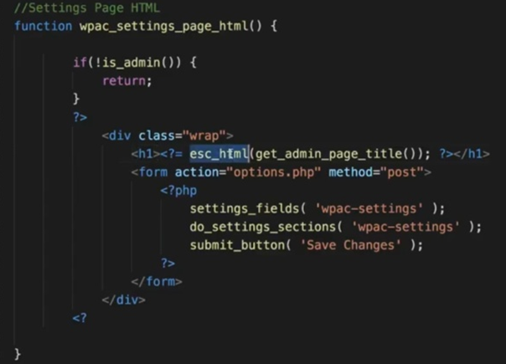

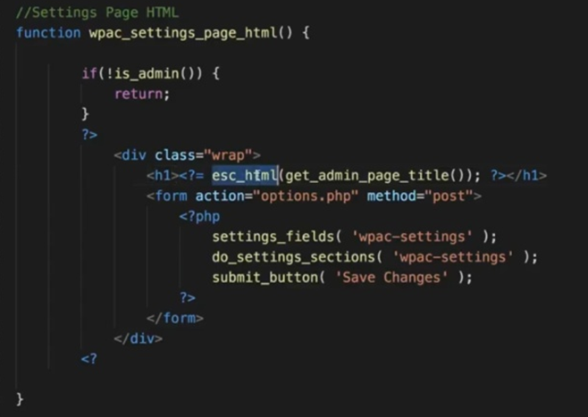

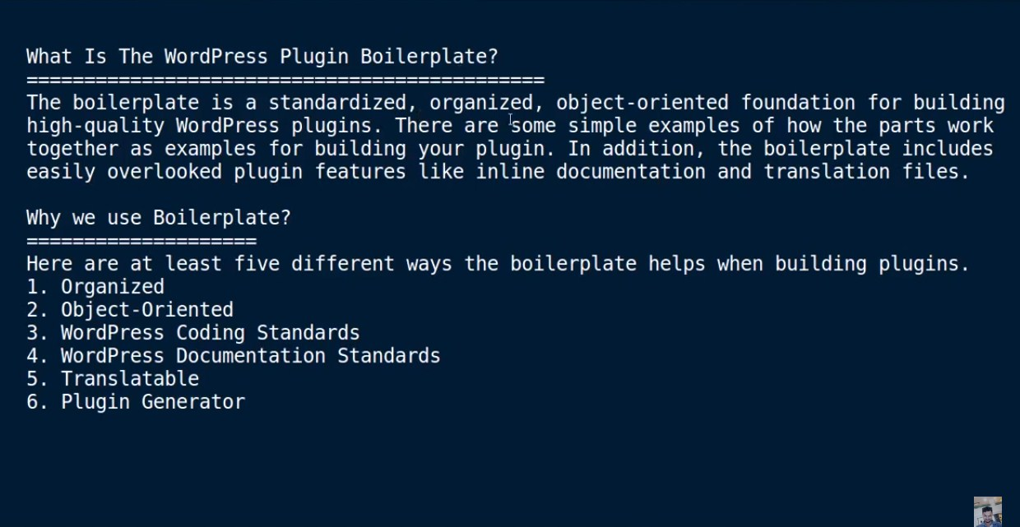

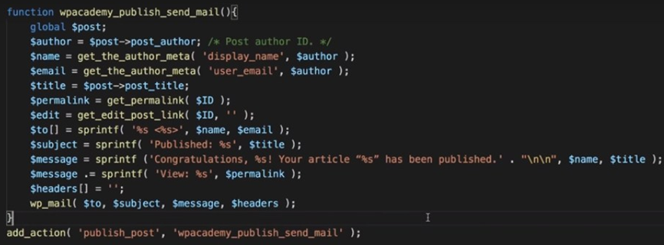

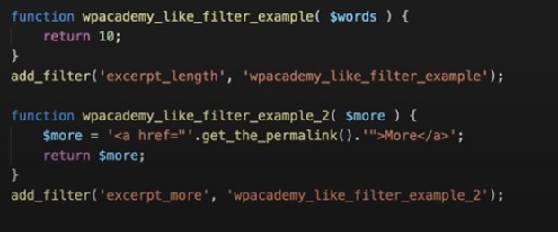

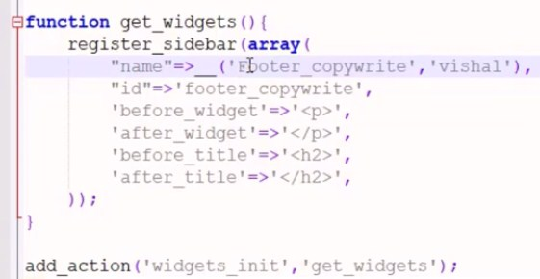

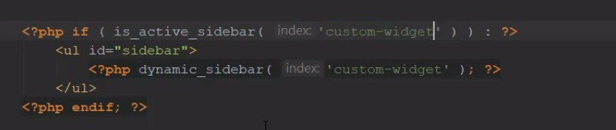

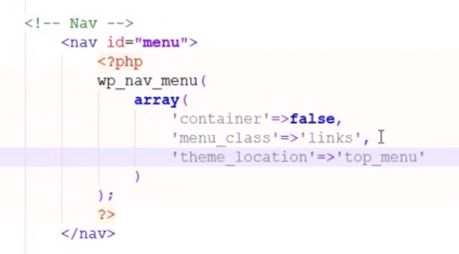

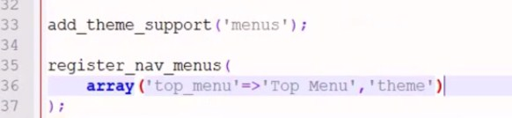

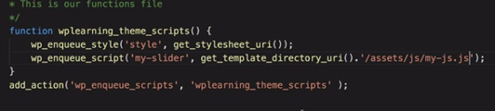

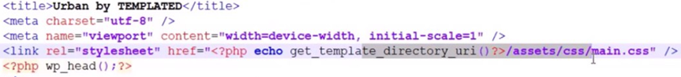

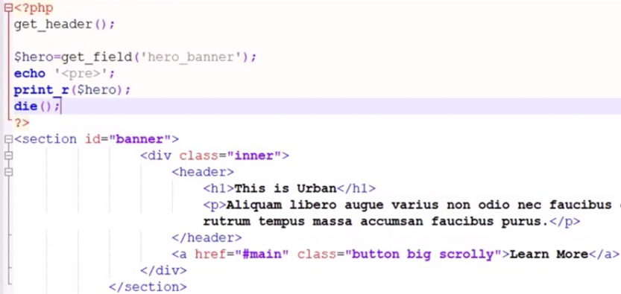

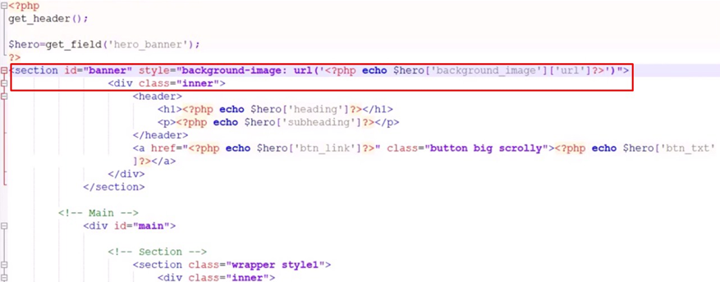

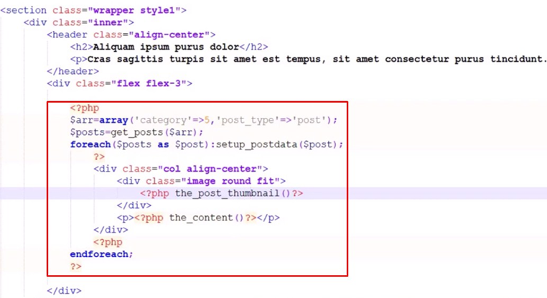

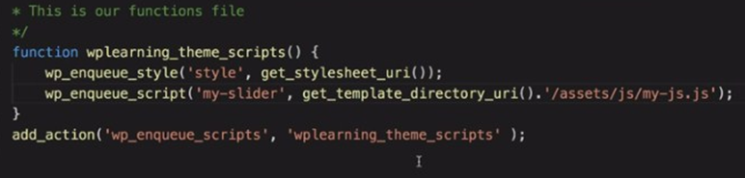

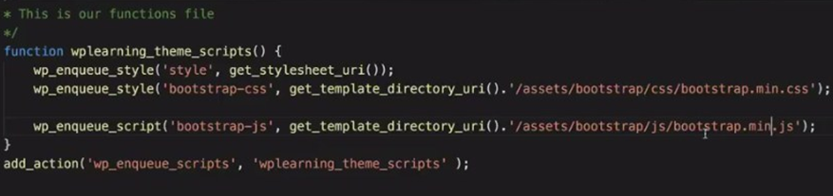

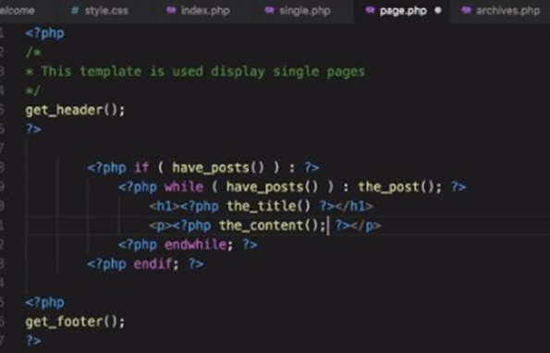

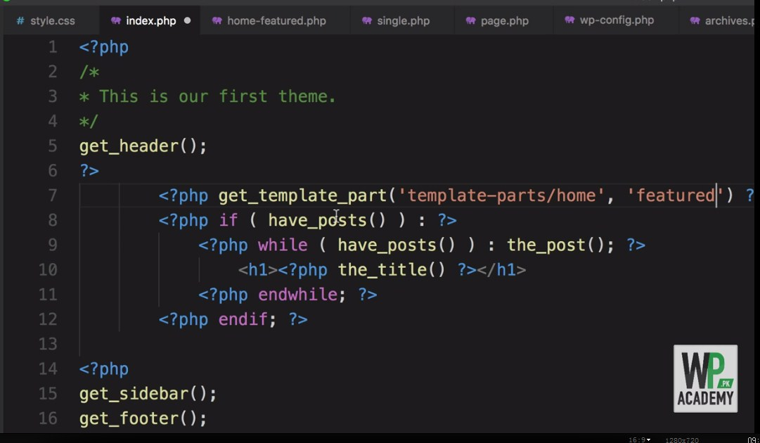

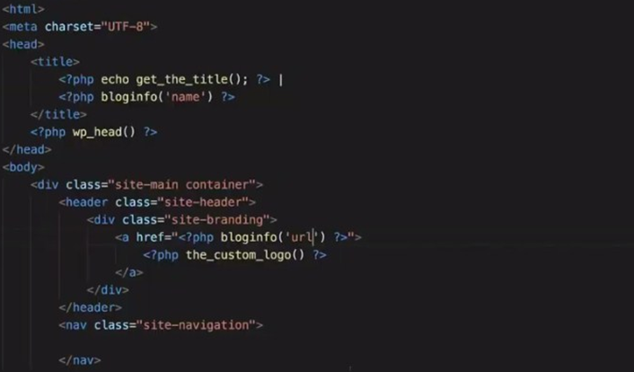

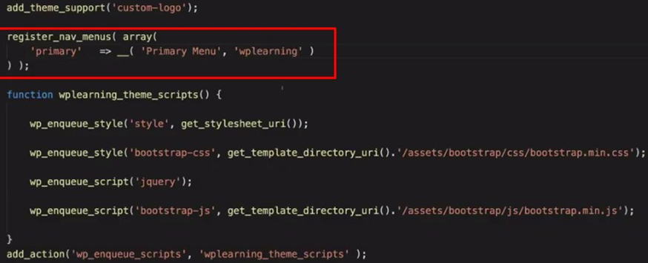

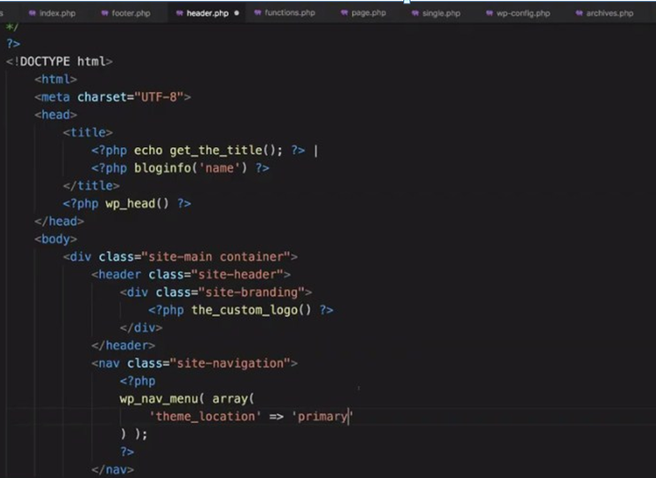

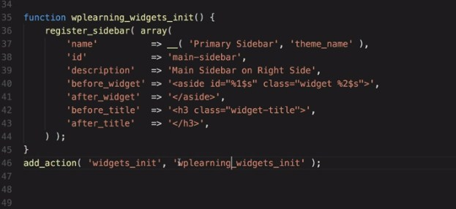

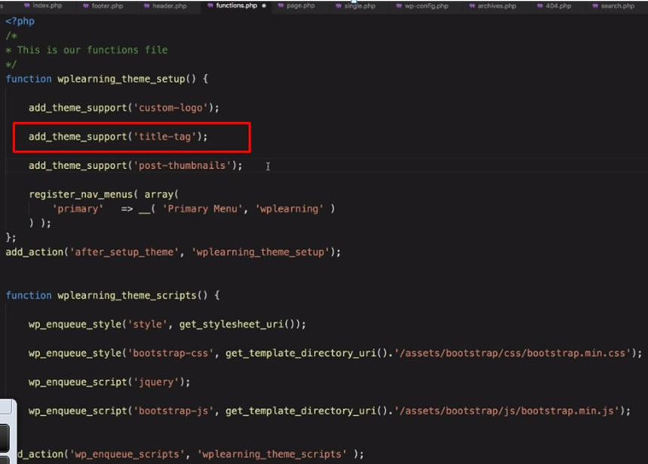

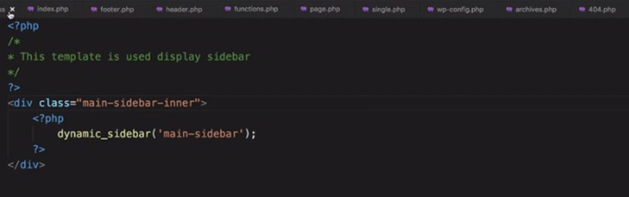

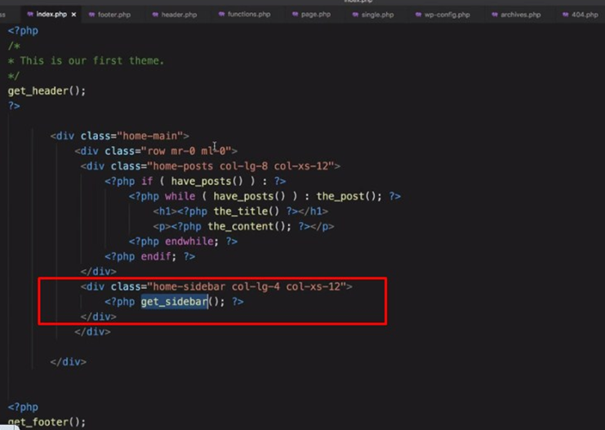

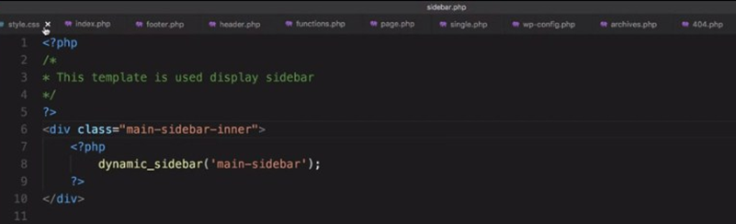

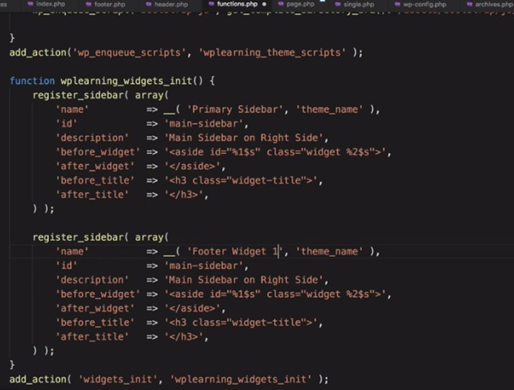

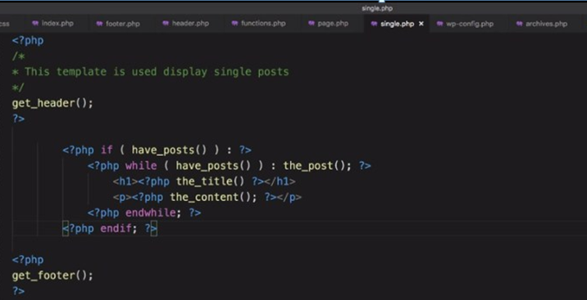

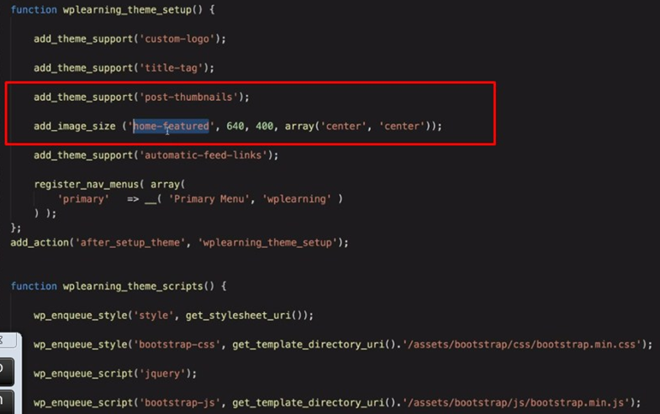

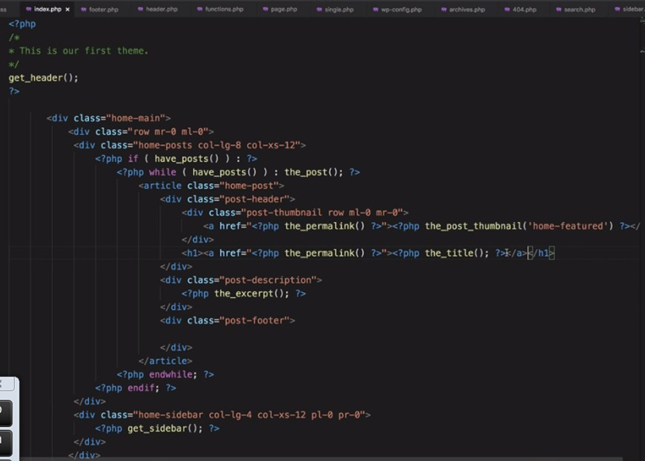

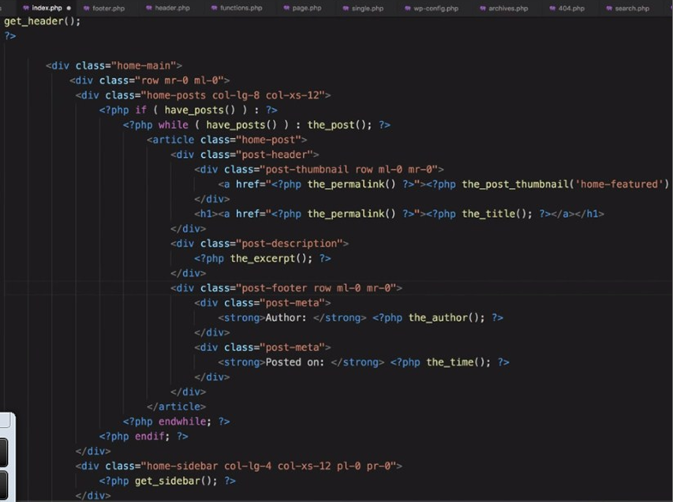

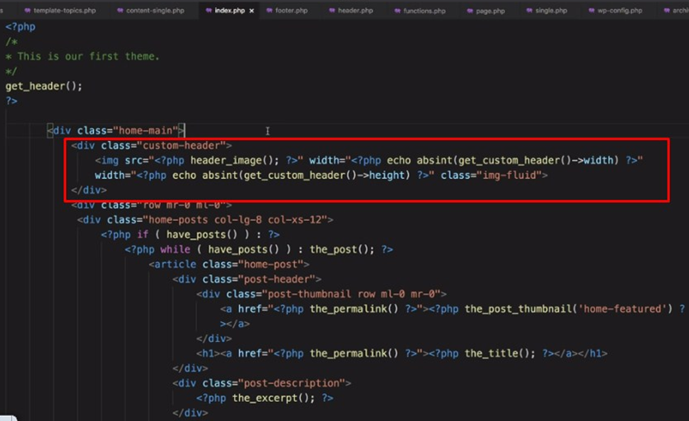

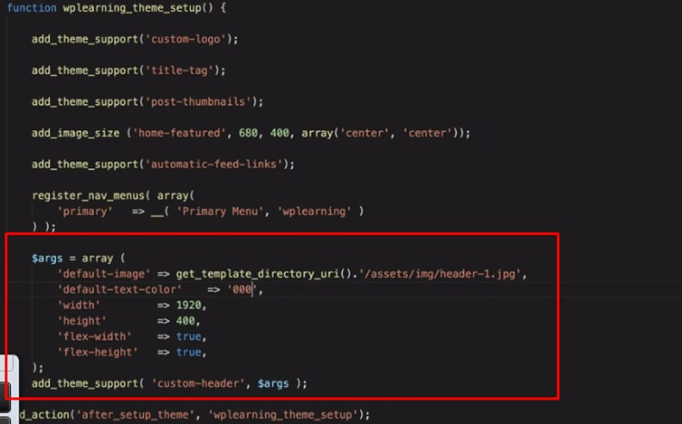

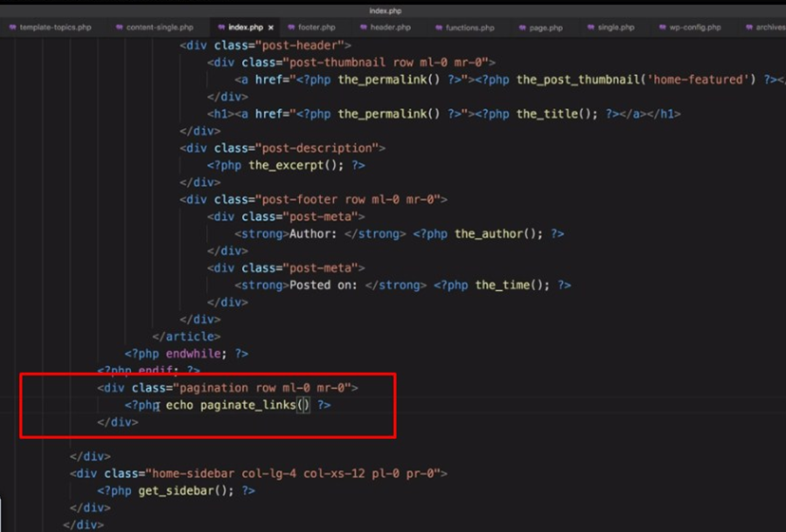

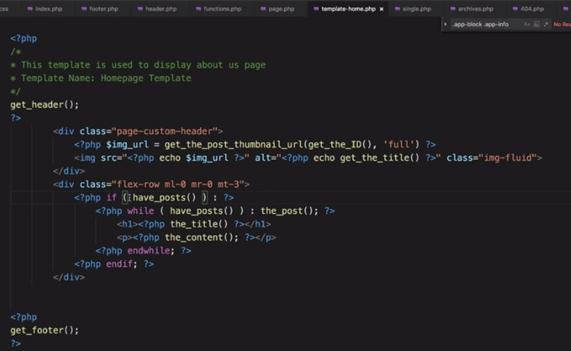

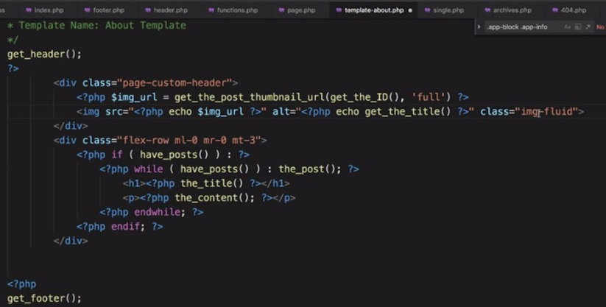

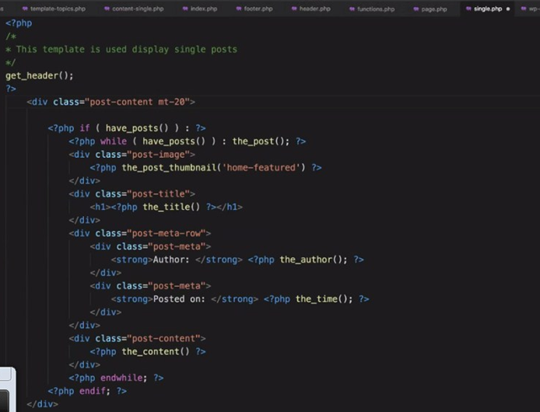

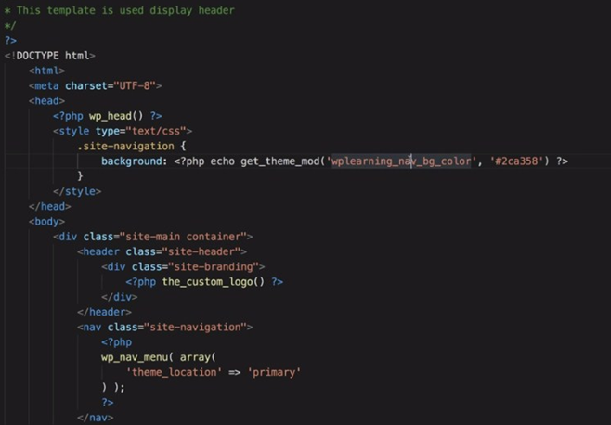

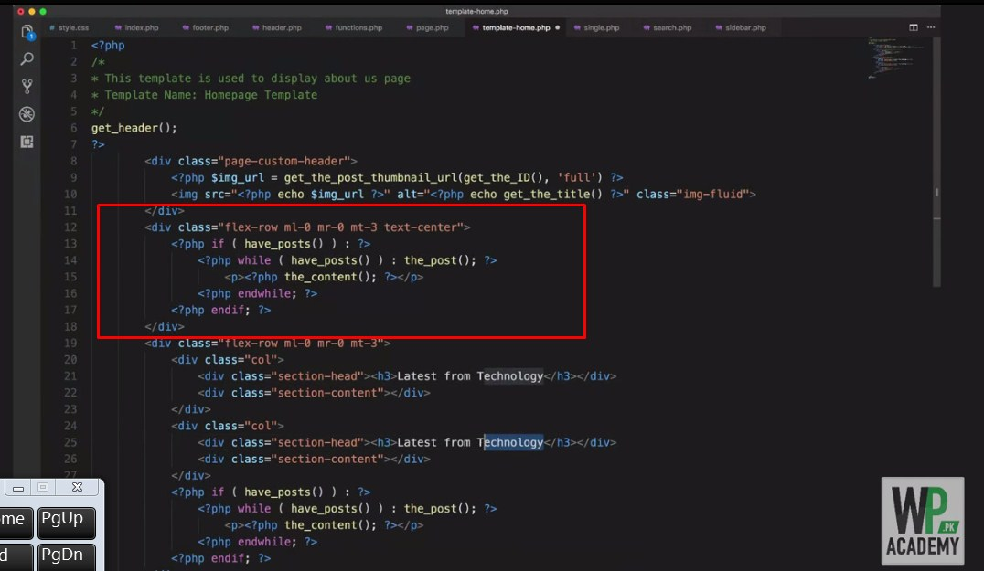

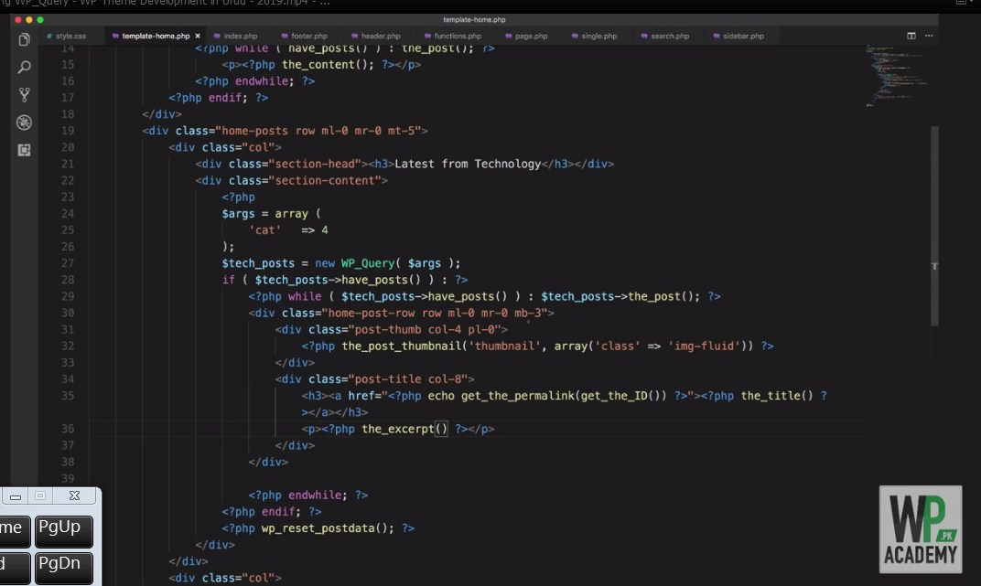

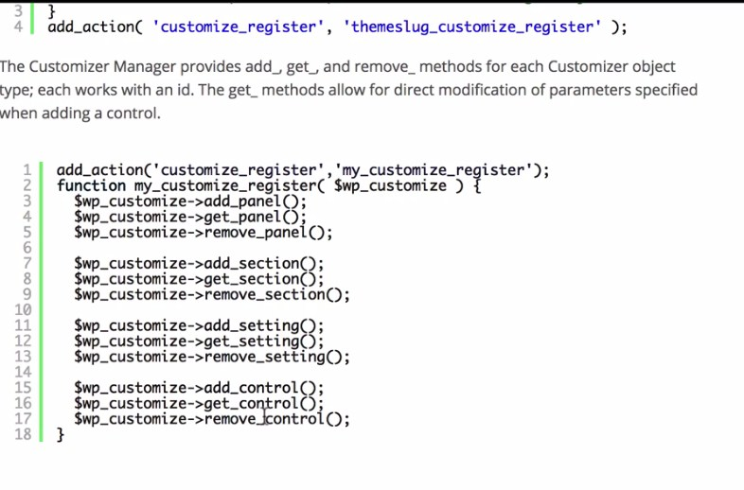

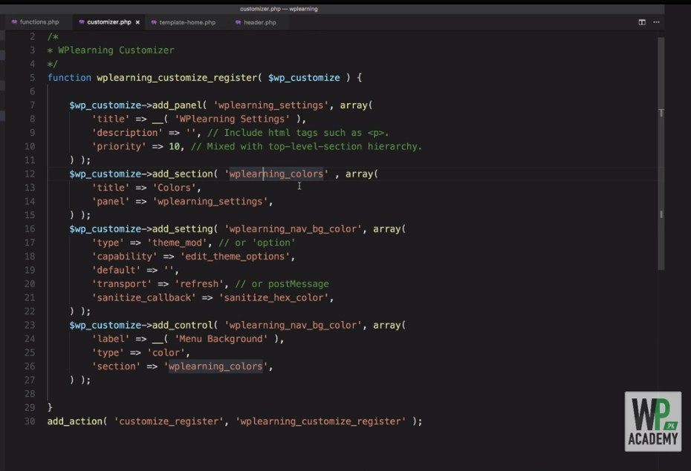

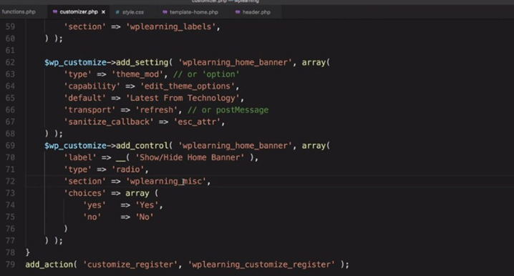

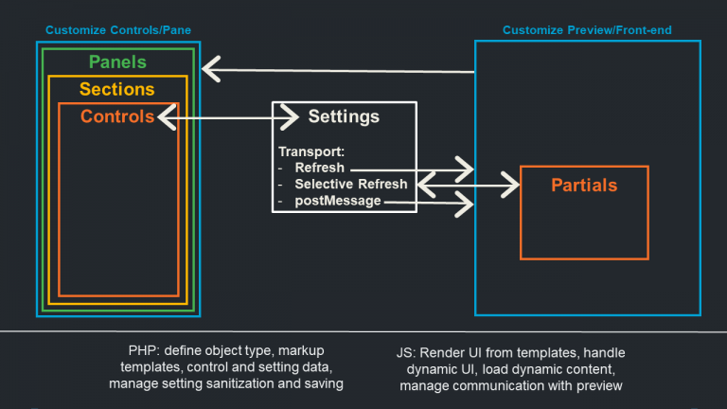

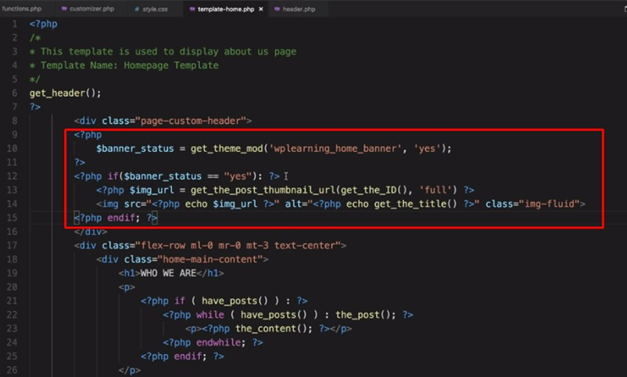

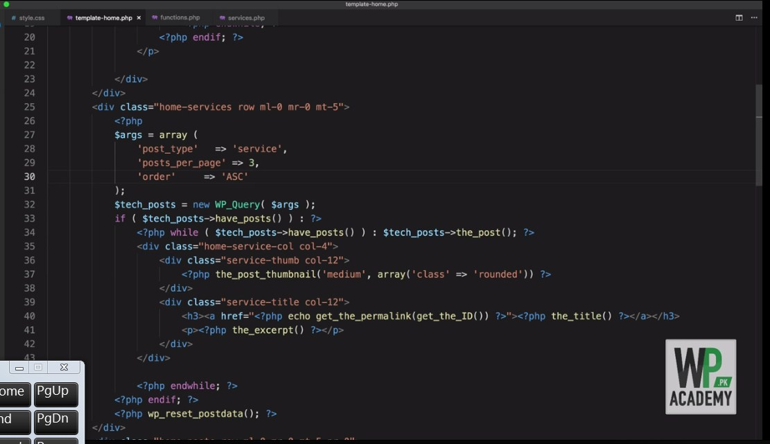

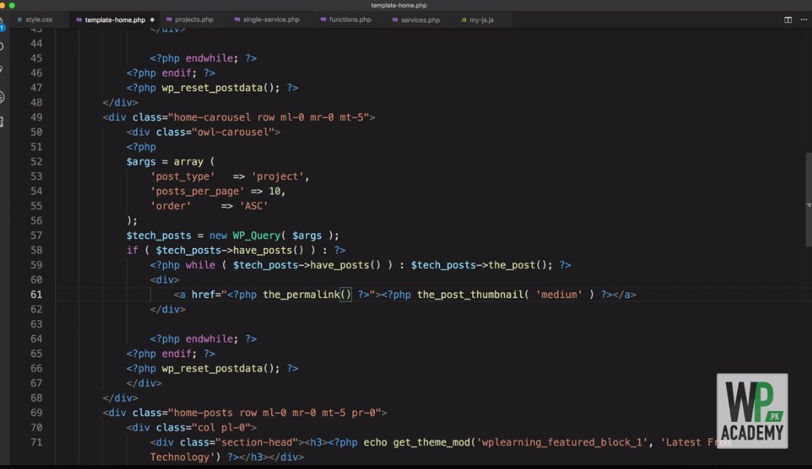

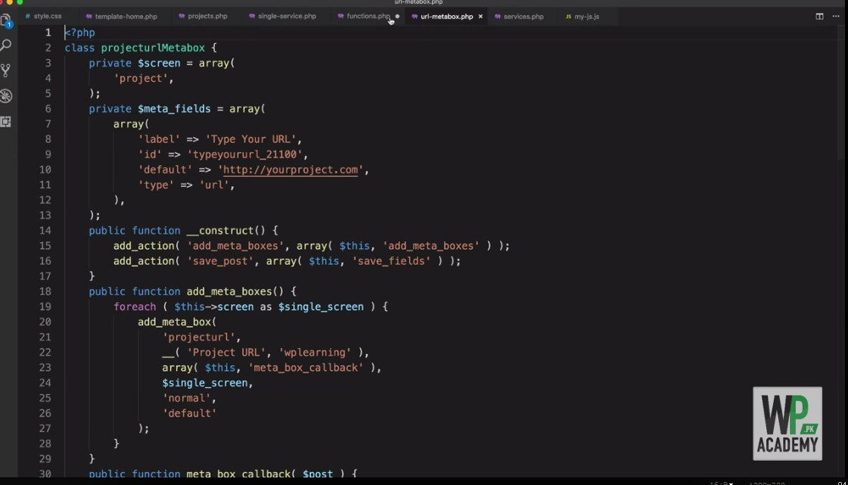

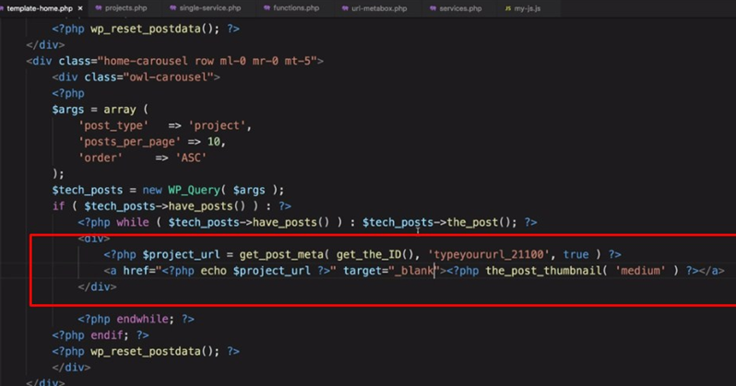

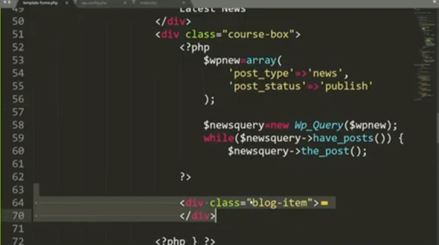

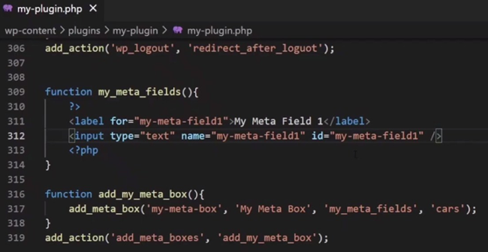

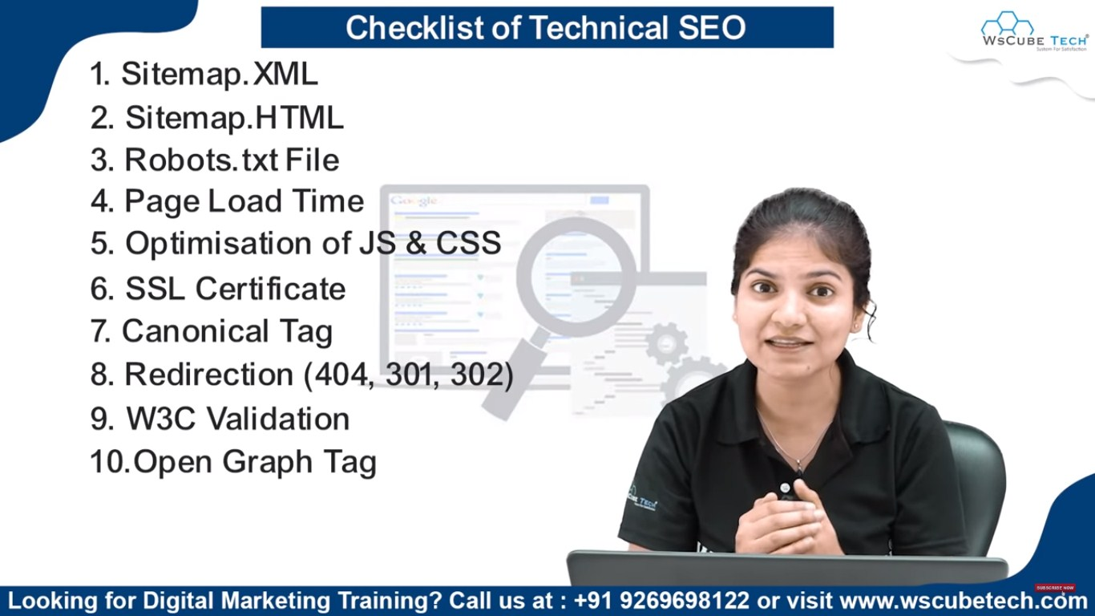

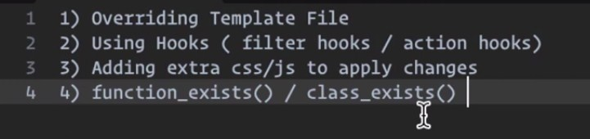

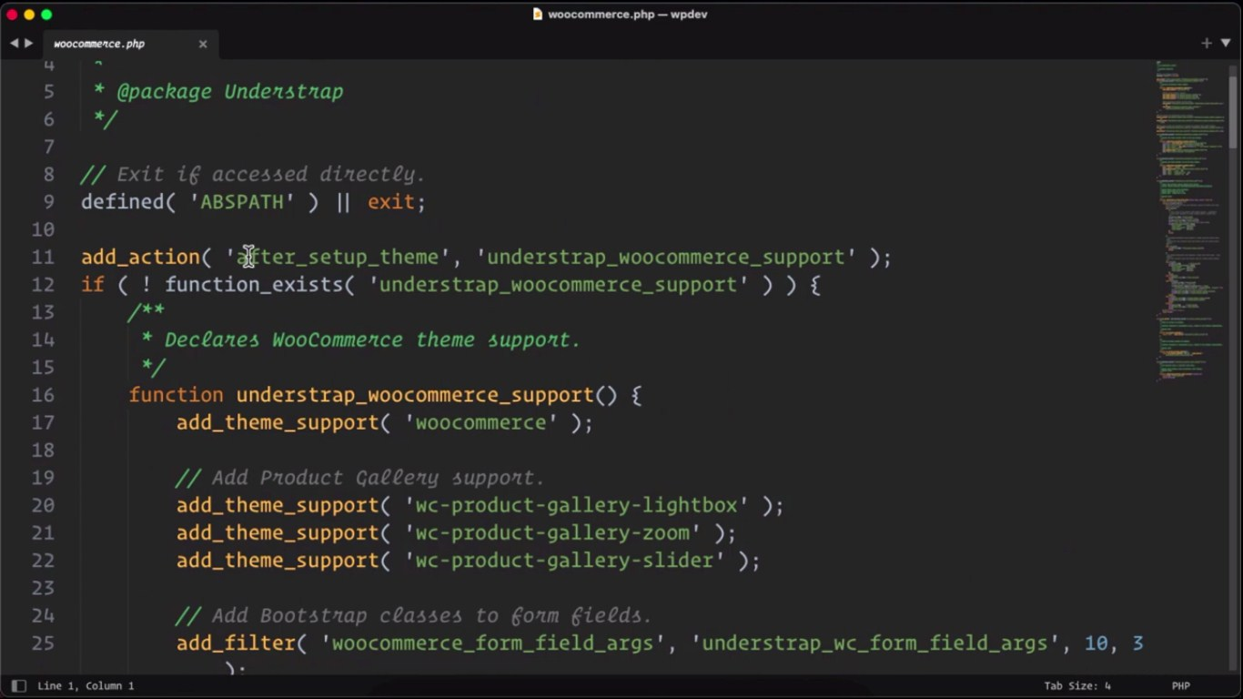

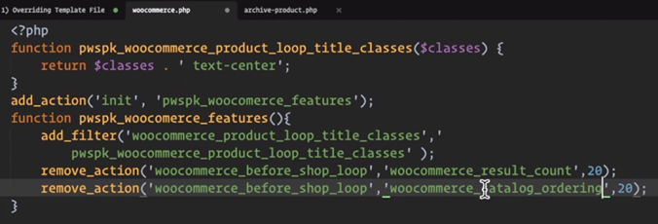

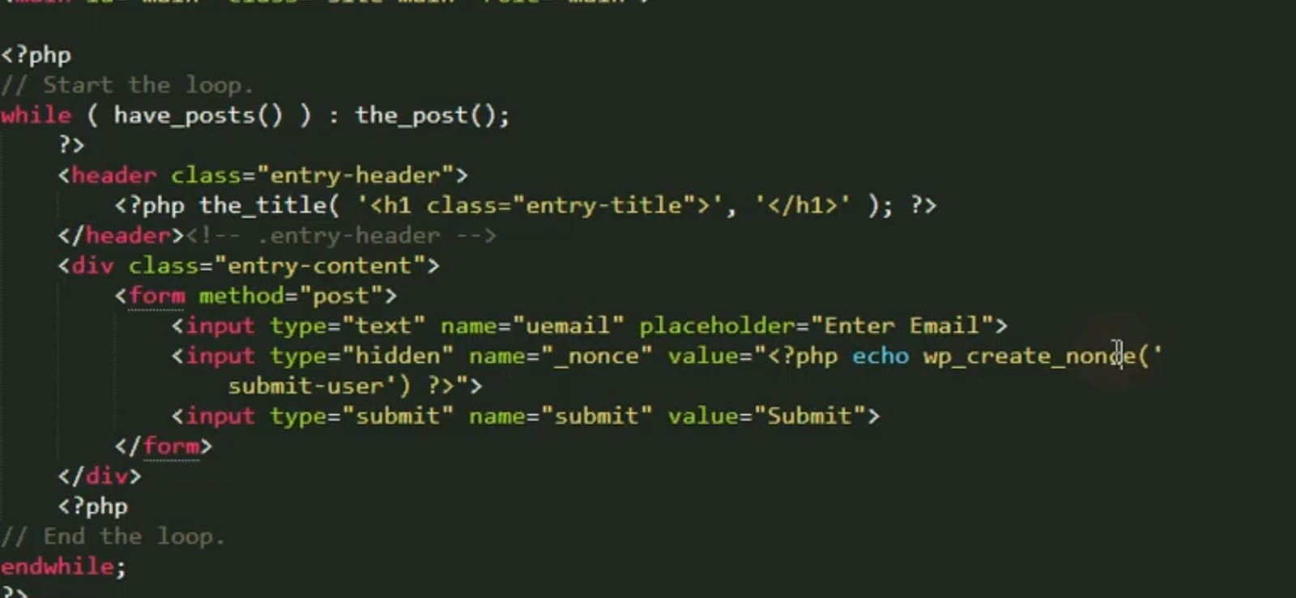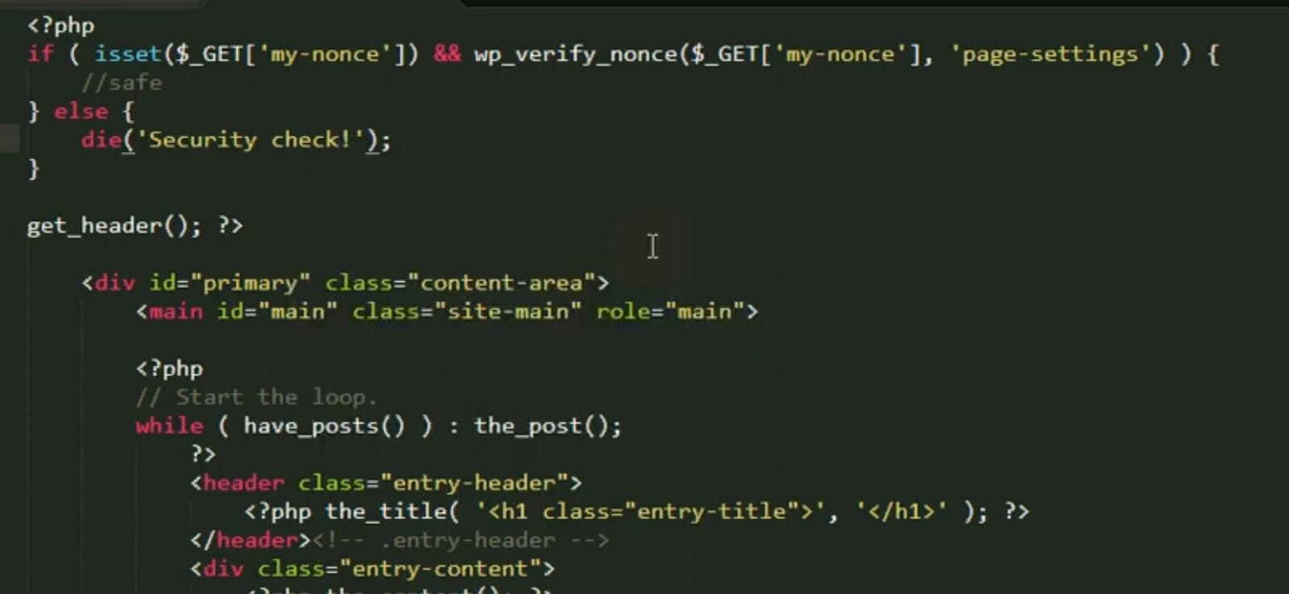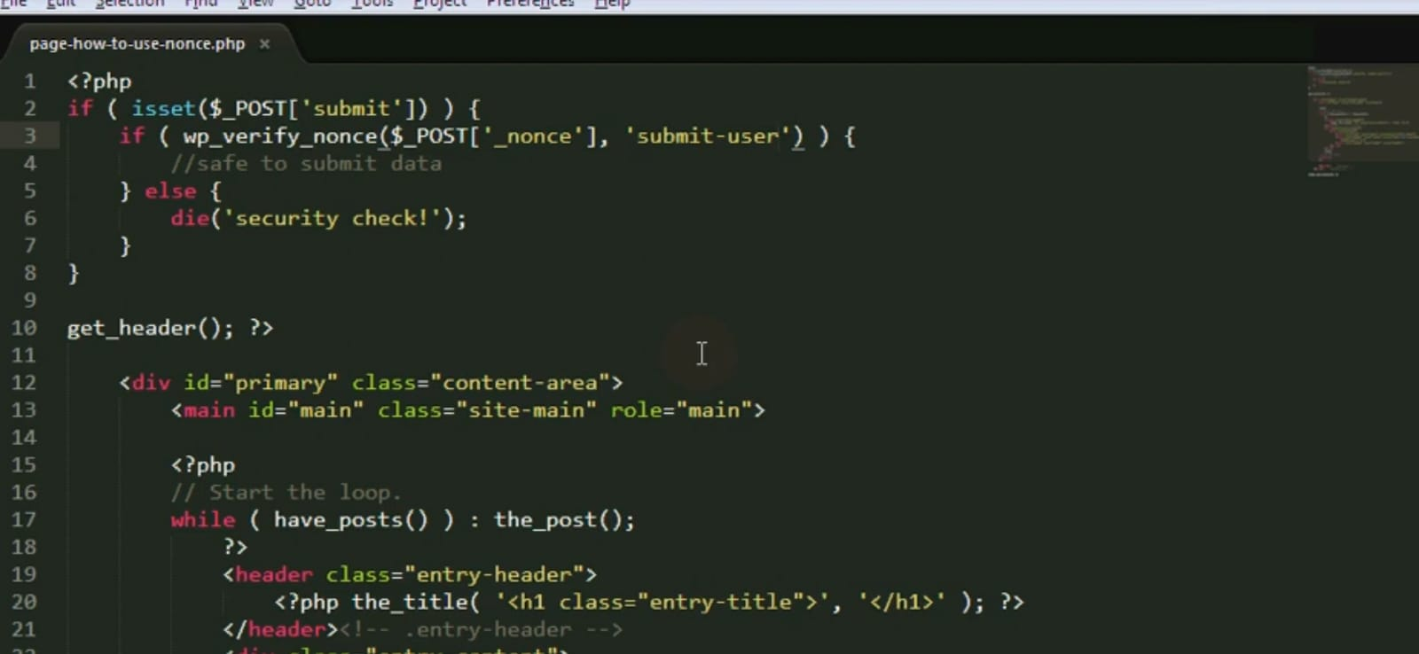

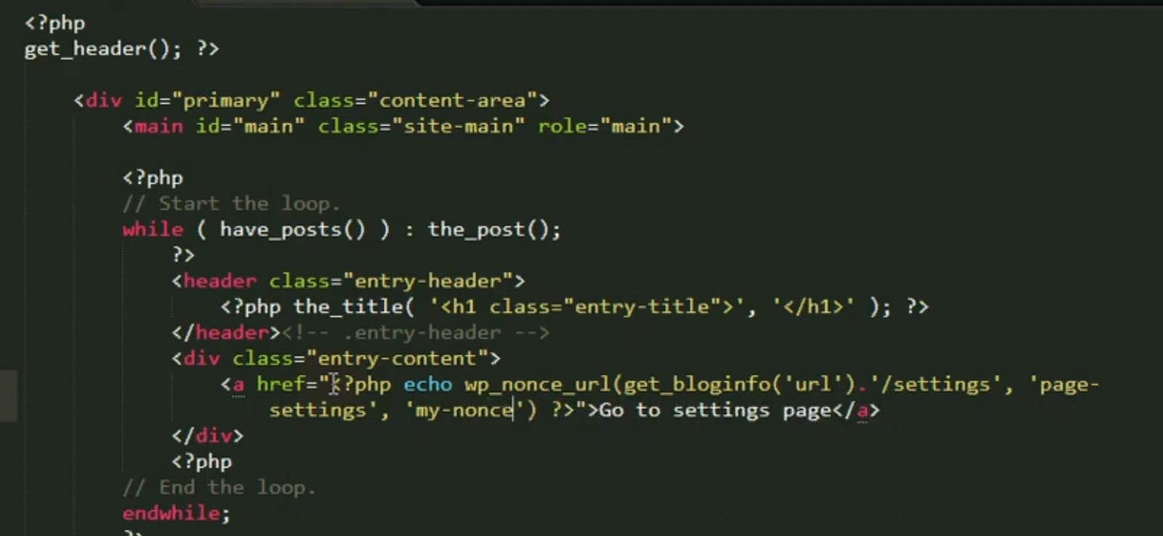

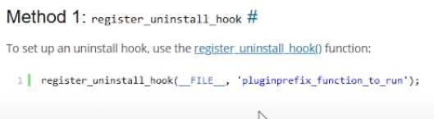

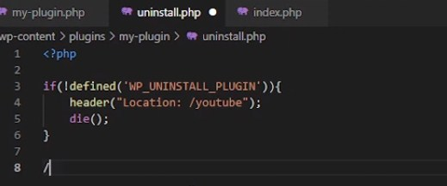

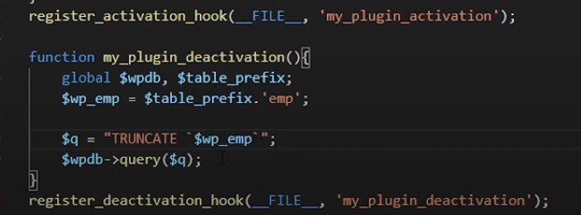

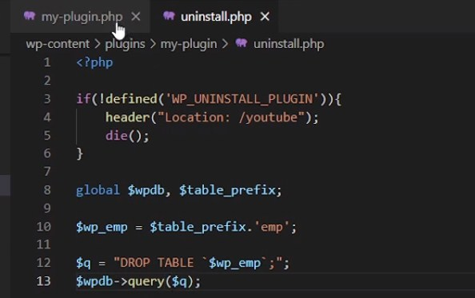

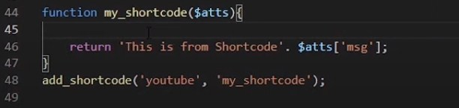

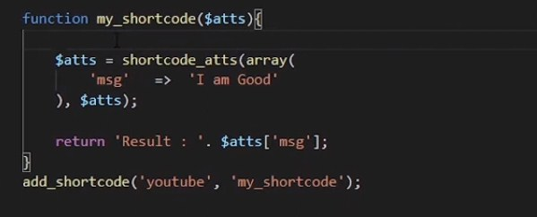

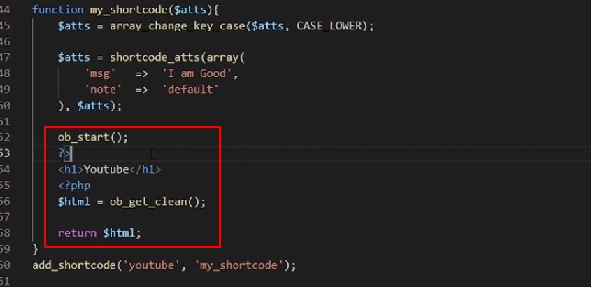

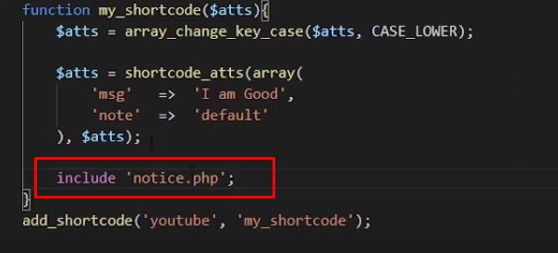

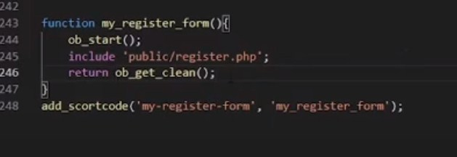

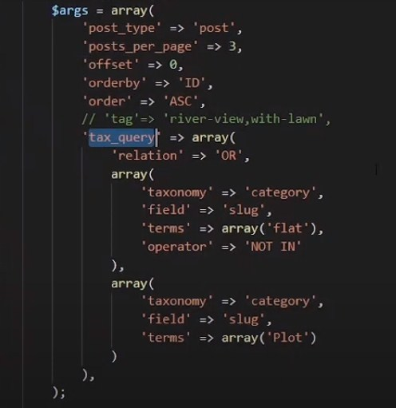

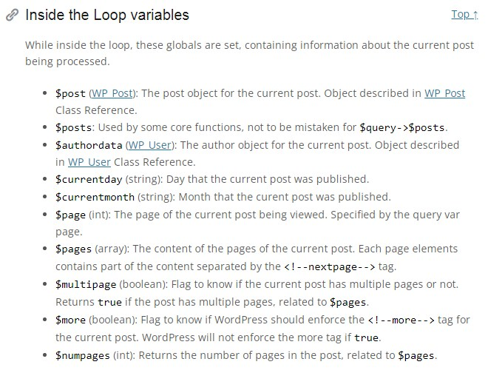



**Git Comman**

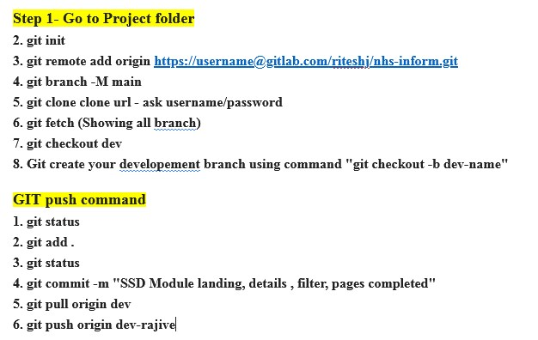

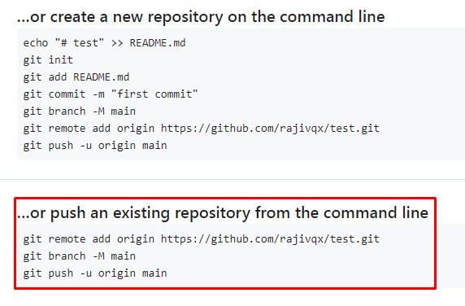

**Git Comman Command**

**Git is a powerful version control system used for tracking changes in source code during software developmentInitialization:**

* + **git init**: Initialize a new Git repository in the current directory.

1. **Cloning:**
   * **git clone <repository_url>**: Clone a remote repository to your local machine.
2. **Configuration:**
   * **git config --global user.name "Your Name"**: Set your global username.
   * **git config --global user.email "youremail@example.com"**: Set your global email address.
3. **Basic Workflow:**
   * **git status**: Check the status of your working directory and see which files have changed.
   * **git add <file>**: Stage changes for commit.
   * **git commit -m "Commit message"**: Commit staged changes with a message.
   * **git diff**: Show the differences between the working directory and the last commit.
4. **Branching and Merging:**
   * **git branch**: List all branches in the repository.
   * **git branch <branch_name>**: Create a new branch.
   * **git checkout <branch_name>**: Switch to a different branch.
   * **git merge <branch_name>**: Merge changes from one branch into another.
   * **git branch -d <branch_name>**: Delete a branch (use **-D** for a force delete).
5. **Remote Repositories:**
   * **git remote**: List remote repositories.
   * **git remote -v**: List remote repositories with URLs.
   * **git push <remote_name> <branch_name>**: Push your changes to a remote repository.
   * **git pull <remote_name> <branch_name>**: Pull changes from a remote repository.
6. **Tagging:**
   * **git tag**: List all tags in the repository.
   * **git tag <tag_name>**: Create a new tag at the current commit.
   * **git tag -a <tag_name> -m "Tag message"**: Create an annotated tag with a message.
7. **History:**
   * **git log**: View commit history.
   * **git log --oneline**: View a concise commit history.
   * **git blame <file>**: See who last modified each line of a file.
8. **Undoing Changes:**
   * **git reset <commit>**: Unstage changes but keep modifications.
   * **git reset --hard <commit>**: Discard changes and move the branch to a specific commit.
   * **git revert <commit>**: Create a new commit that undoes the changes introduced by a specific commit.
   * **git checkout -- <file>**: Discard changes in a specific file.
9. **Stashing:**
   * **git stash**: Temporarily save changes that are not ready to be committed.
   * **git stash pop**: Apply the most recent stash and remove it from the stash list.
10. **Advanced Topics:**
    * **git submodule**: Manage Git submodules within your repository.
    * **git rebase**: Reorganize and rewrite commit history.
    * **git cherry-pick**: Apply specific commits to your current branch.

**git help <command> or git <command> --help to access the official Git documentation.**

**Linex Comman Command**

1. **File and Directory Operations:**
   * **ls**: List files and directories.
   * **pwd**: Print the current working directory.
   * **cd**: Change the current directory.
   * **touch**: Create an empty file.
   * **mkdir**: Create a new directory.
   * **rmdir**: Remove a directory.
   * **rm**: Remove files or directories.
   * **cp**: Copy files or directories.
   * **mv**: Move or rename files or directories.
2. **File Viewing and Editing:**
   * **cat**: Concatenate and display file content.
   * **more** or **less**: View text files page by page.
   * **head** and **tail**: Display the beginning or end of a file.
   * **nano** or **vim** (or **vi**): Text editors for creating and editing files.
   * **grep**: Search for text patterns in files.
   * **find**: Search for files and directories.
3. **File Permissions:**
   * **chmod**: Change file permissions.
   * **chown**: Change file ownership.
   * **chgrp**: Change group ownership.
4. **System Information:**
   * **top**: Display real-time system information and processes.
   * **df**: Display disk space usage.
   * **free**: Display RAM usage.
   * **uname**: Display system information.
   * **lscpu**: Display CPU information.
5. **Package Management:**
   * **apt** (Debian/Ubuntu): Package management tool for installing, updating, and removing software packages.
   * **yum** (RHEL/CentOS): Package manager for Red Hat-based distributions.
   * **dnf** (Fedora): Package manager for Fedora.
6. **Network Utilities:**
   * **ping**: Send ICMP echo requests to a host.
   * **ifconfig** or **ip**: Network configuration and information.
   * **netstat**: Network statistics and routing tables.
   * **ssh**: Secure Shell for remote login.
   * **scp**: Securely copy files between hosts.
7. **Process Management:**
   * **ps**: Display information about running processes.
   * **kill**: Terminate processes.
   * **top**: Monitor and manage running processes interactively.
8. **Archiving and Compression:**
   * **tar**: Create or extract tar archives.
   * **zip** and **unzip**: Create and extract zip archives.
   * **gzip**, **gunzip**, **bzip2**, **bunzip2**: Compress and decompress files.
9. **User and Group Management:**
   * **useradd** and **userdel**: Add and delete user accounts.
   * **passwd**: Change user passwords.
   * **groupadd** and **groupdel**: Add and delete groups.
   * **su** and **sudo**: Switch users or execute commands as superuser.
10. **File System Navigation:**
    * **cd**: Change directory.
    * **ls**: List files and directories.
    * **pwd**: Print working directory.
    * **tree**: Display directory structure as a tree.

